Digital Society
Intergenerational conflict between myth and reality

Cristina Haidu¹,
Maria Micle²
^{1,2}Faculty of Governance and Communication Sciences, West University of Timisoara, Romania

Abstract:
Intergenerational conflict is an inevitable phenomenon, present in all societies and times, based on differences in mentality, values and life experiences. Over time, this conflict has often been interpreted through myths and stereotypes that exaggerate the contrast between the young and the old. On the one hand, young people are often seen as rebellious, non-conformist, disrespectful of traditions and too concerned with new technologies. On the other hand, older generations are often characterized as rigid, difficult to persuade to change, and unable to adapt to new social and cultural realities. However, reality is much more complex than these generalizations. Intergenerational conflict is not only an opposition between old and new, but also an image of the way in which society evolves. Each generation has its own landmarks and challenges, shaped by the historical and technological context in which it lives. In many cases, generational differences are not necessarily an obstacle, but rather an opportunity for mutual learning and adaptation. This is why it is important to analyse both the myths that fuel these tensions and the realities that engender them, trying to identify solutions for generations to better understand each other and collaborate. This paper aims to explore, with the help of a survey, the manifestations of “intergenerational conflict”, balancing both traditional perspectives and the changes that shape relations between young and elderly people in contemporary society, a society strongly influenced by digital communication.

Keywords: digital communication, digital ageism, age-related stereotypes intergenerational dialogue

Introduction: Perspectives on Generational Differences
Generational conflict is a complicated social phenomenon that reflects differences in thinking, principles and actions between different age groups. It can occur in multiple settings – family, professional, cultural or societal – and it is influenced by economic, technological, and historical factors.
In specialized research, generational conflict is defined in various ways. According to sociologist Karl Mannheim (1952, p. 291), it represents a natural tension between age groups, tension generated by different experiences and values accumulated throughout life. Mannheim emphasizes that each generation is shaped by the historical context in which it grows up, a context that leads to different views of social reality. Other experts associate intergenerational conflict with the phases of psychosocial development, and according to his theory, each person goes through several stages of development, and differences between generations arise, largely, from the needs to assert their identity and adapt to social changes. Moreover, generational conflict is also defined from a cultural perspective. According to Margaret Mead (1970, p. 25), this gap results from the discrepancies between the generations that transmit culture (adults) and those that receive and modify it (young people). As society evolves quickly, new generations are prone to reject or change traditional values, which causes tensions with the older generation. Generational differences have been approached from multiple angles, each offering an explanation of how they arise and influence social relations – sociological, psychological, cultural.
From a sociological perspective, each generation is shaped by the historical, economic, and technological context in which it develops. Events such as wars, economic crises, or technological revolutions influence the values and behaviours of a generation, which can lead to discrepancies between it and previous generations. For example, generations that have lived in periods of economic instability tend to be more financially prudent, while those that grew up in a period of quick development are more prone to consumption and innovation.
From a psychological perspective, generational conflict is explained by differences in perception, motivation, and information processing. As individuals age, the experiences they accumulate lead them to be more cautious and more tied to traditions, while young people, in the midst of identity development, are more open to change and exploration. This dynamics can lead to misunderstandings and opposing views on how society should function.
From a cultural perspective, generational differences are accentuated by the way in which social values ​​and norms are transmitted and reinterpreted. In the past, culture was mainly transmitted from the old ones to the young ones but, with technological development and easy access to information, young people have become increasingly independent in shaping their own cultural identity. This change has led to a generation gap, in which values ​​and customs are changing more quickly than in the past.
Nowadays, a crucial factor in accentuating generational differences is technological progress. Young people, familiar with digital technology from an early age, easily adopt new forms of communication and interaction, while older generations may have difficulty adapting to this quick pace of change. This difference is manifested not only in communication preferences, but also in perceptions of work, education, and interpersonal relationships. In today’s world, generations are often classified based on common traits determined by the historical, social, and technological context in which they have grown up. These divisions facilitate a better understanding of the differences in thinking and behaviour between different age groups. In specialized studies, one of the most widely used classifications is that proposed by sociologists and demographic researchers Strauss and Howe (1991): Baby Boomers (1946-1964), Generation X (1965-1980), Generation Y or Millennials (1981-1996), and Generation Z (1997-2012). Recently, a new generation has also been outlined, Generation Alpha (2013-present).

1. Virtual Environment: an Environment of Intergenerational Interactions

Online communication has become essential for human interactions, influenced by technological progress, globalization, and the evolution of digital platforms. This form of communication has specific features compared to the traditional one, presenting both advantages and limitations. Researchers McQuail (2010) and Castells (2009) have analysed the impact of the Internet on the way people send and receive information messages, highlighting the changes brought about by the digital environment.
One of the key features of online communication is immediacy. Information can be sent and received in real time, regardless of the distance between the participants. The speed of message exchange has revolutionized fields such as journalism, education, and interpersonal relationships, facilitating continuous and dynamic interaction. Moreover, the online environment favours the active participation of the users, transforming them from simple receivers of information into creators of content. Social platforms and blogs have led to the decentralisation of communication, allowing anyone to express their opinions and to influence public discourse. (Jenkins, 2006)
Another distinctive aspect of online communication is anonymity, which can significantly modify users’ behaviour. Suler (2004) introduced the concept of “online disinhibition effect”, according to which the lack of physical interaction makes people freer in their expression, but can also lead to negative behaviours, such as trolling and hate speech. The digital environment also allows the construction of a virtual identity that may not always correspond to the real identity of the individual, thus influencing perceptions and social relationships.
Online communication differs from traditional communication in that it lacks nonverbal cues, such as facial expressions, gestures, or tone of voice. Mehrabian (1971) emphasizes that much of the meaning of communication comes from these cues, and their absence in digital interactions can lead to misinterpretations or ambiguity of messages. Although emojis and digital reactions were introduced to compensate for this deficiency, they cannot accurately reproduce the complexity of face-to-face human interaction.
The quick diffusion of information is another defining feature of online communication. The phenomenon of virality allows certain messages to be distributed widely in a very short time. Berger and Milkman (2012) demonstrated that types of content that provoke intense emotions – such as surprise, anger, or amusement – are more likely to go viral. This process facilitates the quick access to useful information, but it also favours the spread of misinformation and of fake news, having a significant impact on public perception.
Another important feature of online communication is the personalization of content, influenced by digital algorithms. Pariser (2011) described the phenomenon of the “filter bubble”, through which users receive information according to their preferences and previous behaviours. This segmentation of content can limit exposure to different perspectives and contribute to the polarisation of opinions, thus affecting the diversity of public debates.

Digital Generations: from Digital Migrants to Digital Natives and Digital-First Generation

The concept of digital generations emerged with the quick advancement of technology and affected the way people interact, learn, and process information. Marc Prensky (2001) introduced the terms “digital migrants” and “digital natives” to describe the differences between those who grew up in a digital environment and those who had to adapt to new technologies later in life.
Digital migrants are those who grew up in a world without ubiquitous digital technology and had to learn to use new technological tools as adults. According to Tapscott (2009), this category often has difficulty adopting new technologies and prefers traditional methods of communication, such as email or face-to-face meetings instead of instant messaging applications or social media platforms used by digital natives.
On the contrary, digital natives are people born after the 1980s, exposed from an early age to digital technologies, such as the Internet, smartphones, and social networks. They are naturally familiar with the digital environment and are used to processing information quickly, preferring visual interactive content. Prensky (2001) mentions that digital natives think differently than previous generations, having a greater tendency towards multitasking and an increased capacity to adapt to technological changes.
The distinction between these two categories has major implications for education, work, and communication. For example, studies by Bennett, Maton and Kervin (2008) challenge the idea that digital natives are automatically more technologically savvy, arguing that frequent use of technology does not necessarily mean a deep understanding of it. In the professional setting, the generational gap has created challenges related to the integration of new technologies in companies, where digital migrants may be reluctant to change, and digital natives may have different expectations regarding flexibility and online collaboration.
A new generation, called by McCrindle and Wolfinger (2010) the “digital-first generation”, includes young people who have grown up in a fully connected environment, where technology is no longer an additional tool, but an important part of everyday life. This category is characterized by an increased dependence on mobile devices, a preference for digital interactions, and a tendency to consume information quickly.

2. Age Stereotypes and Biases

Age stereotypes and biases are simplified and, often, erroneous generalisations about individuals, based solely on their belonging to a particular age group or generation. These fixed notions can influence the way individuals are perceived, treated, and valued in different social, cultural, and professional contexts or settings.
Stereotypes about older people tend to associate them with features such as rigidity, resistance to change, cognitive decline, or lack of digital skills (Posthuma & Campion, 2009). These views can lead to the unwanted exclusion of older people from decision-making processes or from opportunities for learning and career advancement. On the other hand, young people – especially Generation Y and Generation Z – are often viewed as immature, emotionally unstable, or unengaged in their work. (Ng, Schweitzer and Lyons, 2010)
Age-related biases contribute to the creation of psychological and institutional barriers between generations. For example, in a multi-generational workplace, employers may assume that older employees cannot adapt to modern technologies, while they may consider younger people not responsible enough for leadership roles. (Finkelstein et al., 2015)
These stereotypes not only affect group cohesion and intergenerational collaboration, they can also lead to self-stigma: individuals internalise negative social perceptions related to their own generation or age, which can affect their self-confidence and performance (Posthuma & Campion, 2009). Fighting age stereotypes requires a deep understanding of intergenerational diversity and fostering an organizational and social culture based on competence, not age. Initiatives such as intergenerational mentoring, awareness training, and diversity promotion can contribute to reducing these barriers.

3. Intergenerational Age Discrimination

Age discrimination, also known as ageism, is the unequal treatment of individuals based on their belonging to a particular age group or generation. The concept was introduced by gerontologist Robert N. Butler in 1969, who defined it as “bias against a person or group based on their chronological age” (Butler, 1969). This form of discrimination manifests itself both explicitly, through direct exclusion or negative stereotypes, and subtly, through different social expectations, constraints imposed on professional opportunities, or cultural marginalization.
In the context of intergenerational relations, discrimination can occur in both directions: both towards older people (considered outdated or less productive) and towards young people considered inexperienced or unserious. According to Ayalon and Tesch-Römer (2018), ageism can manifest itself in multiple areas from employment and professional promotion, to access to health services, education, and social participation.
In the organizational setting, age discrimination is often disguised as preferences for “cultural compatibility” or “adaptability to technology”, which favours certain generations over others. Thus, divergences between generations can become sources of tension in work teams, perpetuating negative perceptions and affecting social cohesion (North & Fiske, 2015).
Against the backdrop of quick demographic changes and the extension of working lives, it is increasingly important to promote intergenerational equity through policies and practices that value age diversity as an advantage, and not as an impediment.

4. Manifestation of Digital Ageism in the Virtual Environment

Generational discrimination, also called digital ageism, is becoming more common in the online environment, being accentuated by differences in technological skills, communication modes, and age-related biases. Butler (1969) defines ageism as the stereotyping and discrimination of a person or group of people based on age; in the virtual environment, this phenomenon takes different forms, affecting both generations, both the oldest and the youngest.
A major manifestation of generational discrimination in the digital environment is technological exclusion. Older people are often seen as less skilled in using technology, which leads to their marginalization on online platforms and in the digitalized professional setting. Helsper and Eynon (2010) argue that there is a digital divide between generations, where young people are considered “digital natives” and are favoured in terms of access to online resources and integration into virtual communities, while older people are seen as “digital migrants”, facing difficulties in adapting to new technologies.
Another form of generational discrimination is derogatory discourse and stereotypes expressed online. Terms such as “boomer” have been popularized on social media to denigrate opinions or behaviours considered outdated or outdated. Fraser et al. (2020) point out that such labels, although initially joking, can accentuate generational polarization and the exclusion of older people from the digital environment. Young people are also often criticized by older generations for their addiction to technology, being labelled as lazy, uncommitted, or unable to maintain real interpersonal relationships. (Twenge, 2020)
Generational discrimination in the virtual environment is also shown by unequal access to digital opportunities, especially in employment and education. Studies by Van Dijk (2020) show that older people are often excluded from technology-intensive jobs, even if they have the appropriate expertise and skills. At the same time, young people face another form of discrimination, being considered “too inexperienced” for certain positions, which leads to difficulties in entering the labour market.
Another important aspect is online harassment and aggression based on age. According to the report by Pew Research Centre (2021), Baby Boomers and Generation X are more prone to verbal attacks and exclusion from online conversations, while Generation Z and Generation Y are more exposed to social pressure from social networks and to “cancel culture” when expressing opinions considered unpopular.

5. Research Methodology

Considering the assessments resulting from the review of literature on trans-generational features and inter-generational conflict enhanced by the digital environment and technology, we wanted to find out how this theme is reflected in the Romanian space and if there are differences, from the perspective of differences in perception, attitude, and behaviour between generations, emphasizing the differences between myth and reality.
The primary objective of this investigation is to find out and understand to what extent the conflict between generations is a reality experienced by individuals or a social construct fuelled by myths, stereotypes, and generalizations. It also aims to highlight the differences in perception between generations and identify possible solutions to reduce intergenerational tensions. The goal is to provide an objective and reasoned approach, which will contribute to a better understanding of this phenomenon.
To investigate this complex theme, we chose a quantitative method, with a descriptive and exploratory nature, namely the opinion survey, with the questionnaire as a data collection instrument. This method allows the analysis of data obtained directly from the subjects and offers the possibility of identifying patterns and trends regarding the conflict between generations. Our investigation aims to describe existing realities and perceptions, without intervening or changing the behaviours studied. It is a cross-sectional research, the data are collected at a single time, without following the evolution of the phenomenon over time.
The questionnaire applied for data collection was self-administered, structured in both closed questions (with multiple choice or Likert scale) and open questions intended to provide added depth in the analysis of the phenomenon. It was carried out through Google Forms and distributed in digital format, through social networks (Facebook, WhatsApp) and by e-mail, thus ensuring quick and anonymous access to a varied sample of respondents. In total, 136 people took part in the research, coming from different social backgrounds and age groups. The selection of respondents was carried out through conventional non-probabilistic sampling, based on availability and interest in participation. The study subjects were previously informed about the purpose of the investigation, the anonymous nature of the responses, and their use for academic purposes. Participation was voluntary, without any kind of coercion, respecting the fundamental ethical principles of scientific research. The response collection period was March-May 2025.

6. Results and Discussions

Although the quantitative methodology provides an adequate framework for the analysis of intergenerational perceptions, the investigation presents certain limitations such as the absence of a probabilistic sample, the uneven distribution of respondents by age groups, or the possible degree of subjectivity in the interpretation of open questions. These aspects are assumed and will be discussed in the final analysis of the results.
Respondents come from both urban (58.8%) and rural (41.2%) areas. This relatively balanced distribution provides a diverse perspective on the topics analysed in the survey. At the same time, it is important to note that differences between residential settings can influence access to information, employment opportunities, or interaction with various forms of discrimination, aspects that will be relevant in the analysis of the following questions.
The participants had the opportunity to self-identify within an age/generation category.
Baby Boomers, Generation X, Generation Z, Generation Y or Millennials

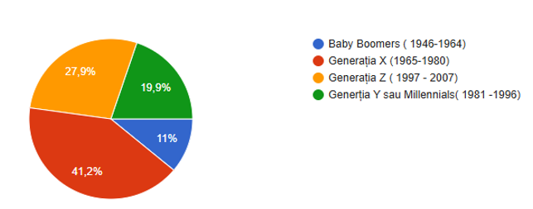
Figure 1. Age/generation categories
Generation X (41.2%) was best represented in the survey. This generation, born approximately between 1965 and 1980, is considered to have a mature perspective on social changes and to be often actively involved in professional and family life.
Generation Z (27.9%), made up of people born after 1996, is the second most represented. They are often more connected to current trends, sensitive to topics such as equity, inclusion and individual rights. Their significant presence adds a modern and critical perspective to the aspects analysed.
Generation Y / Millennials (19.9%), born between approximately 1981 and 1996, comes with a combination of traditional and modern views. They are generally very active in digital and professional life and bring a balance between the idealism of Generation Z and the pragmatism of Generation X.
Baby Boomers (11%), born between 1946 and 1964, are the least represented. However, this category offers a valuable point of view, having extensive life experience and a vision formed in a different social context than younger generations.
To assess the level of ageism awareness, the following question was addressed to the participants: “Do you think that, in today’s society, people are discriminated against on the basis of age?” The answers were as follows:
Yes, No, Don’t know

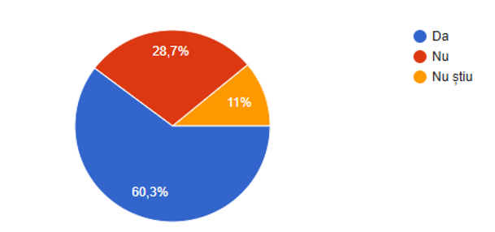
Figure 2.Awareness of age discrimination

Most respondents perceive age discrimination as a reality – over 60% of the participants consider age to be a frequent criterion of discrimination in today’s society. This may reflect a growing awareness of the issue of ageism, whether in a professional, social, or cultural setting. A significant minority (almost 29%) do not perceive age discrimination. This difference in perception could indicate variations in personal experiences or in the level of sensitivity towards the subject. A small percentage is undecided – the 11% who answered “I don’t know” could suggest either a lack of information, or an ambiguity in the perception of the phenomenon in everyday life.
In order to assess perceptions related to ageism, the questionnaire included a question regarding the age group perceived as being the most affected. Participants were asked to indicate which age category they consider to be the most frequently discriminated against in today’s society. The results are illustrated in the following graph:

Which, in your opinion, of the following age groups is the most discriminated?
Young people (below 30 years), Adults (31-50 years), Old people (65+ years), None

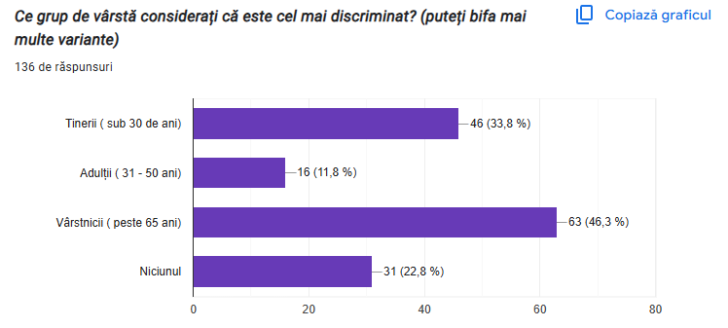
Figure 3.Perceptions related to age discrimination

According to the data collected, most respondents (46.3%) consider that elderly people, over 65 years of age, are the most affected by discrimination. Second come young people under 30, mentioned by 33.8% of participants. Only 11.8% of respondents indicated that adults between the ages of 31 and 50 are age discriminated, and 22.8% of participants believe that no age group is particularly age discriminated.

In this study, we were interested in finding out which media sources and social media platforms are most frequently used for information and communication. The question asked was: What media channels and social networks do you use to get information and communicate?
Radio, TV. Facebook, Instagram, Tik-Tok, YouTube, ChatGPT, WhatsApp, LinkedIn, networks…, Euronews.ro, Reddit, Media channels, Newspapers, Books, Google, International sites, Books, Independent media sources, Linkedin, Written press

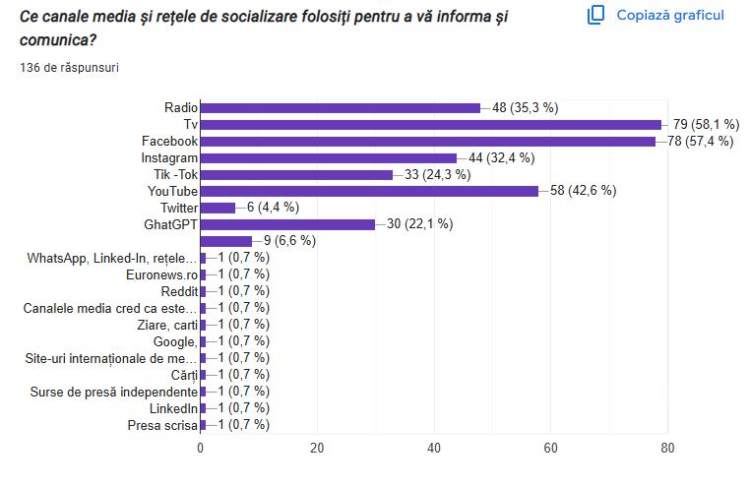
Figure 4.Media sources and social media platforms are used.

The results show that the most used sources of information and communication are:
◦ Television – 58.1%;
◦ Facebook – 57.4%;
◦ YouTube – 42.6%;
◦ Radio – 35.3%;
◦ Instagram – 32.4%;
◦ TikTok – 24.3%;
◦ ChatGPT – 22.1%.
It is obvious that television and social networks rank first, indicating a clear preference for audio-visual and interactive formats. Facebook and YouTube are the dominant online platforms, followed by Instagram and TikTok, suggesting a significant presence of visual and video content in media consumption habits. Interestingly, ChatGPT is mentioned by 22.1% of respondents, indicating a growing openness towards digital sources based on AI. On the other hand, Twitter is used by only 4.4%, and other sources such as WhatsApp, LinkedIn, written press, books, and Google were mentioned in a tiny proportion (below 1%). This points to either a low level of actual use or a poor perception of these sources as relevant information and communication media.
In order to capture the qualitative aspects of age-related perception, an open-ended question was introduced in the questionnaire: “Have you ever felt discriminated based on your age?”. This question was intended to allow participants to freely report any situations of marginalization, bias, or incorrect judgment based on age. The analysis of the responses provides a valuable interpretative framework, complementing the statistical data obtained through the closed items.

Have you ever felt discriminated based on your age?
Yes, No

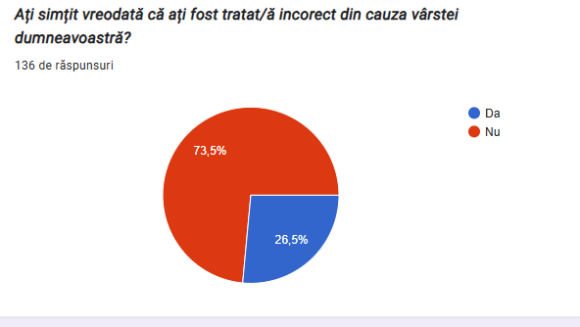
Figure 5.Figure 3.Perceptions related to age discrimination

The purpose of this question was to highlight any subjective experiences related to discrimination or underestimation based on age, especially in professional contexts.
Of the total number of respondents, 73.5% responded negatively, stating that they had not encountered such situations, while 26.5% responded affirmatively, mentioning concrete experiences in which age negatively influenced the way they were perceived or treated.
The affirmative responses mainly highlighted situations in which young people, around the age of 25, were treated superficially or were underestimated at work. For example, some respondents mentioned that they could not apply to certain professional projects because they were too young or, on the contrary, too old, while others reported that, in their first years of activity, especially in institutional settings such as schools, they were treated like “children” by their colleagues, in terms of their qualifications.

7. Conclusions

Intergenerational conflict is a complex phenomenon with deep roots in the cultural, social, and psychological structure of humanity. The present study has shown how tensions between generations are reflected both in myths and symbolic representations, as well as in the realities of today’s society.
First of all, the analysis of the mythological dimension of the intergenerational dispute has shown that the opposition between young and old is not a modern construct, but a repetitive element in the collective imaginary. Fundamental myths, like those of Oedipus or Prometheus, symbolically capture the rupture and tension between the old structures of authority and the emerging forces of change and autonomy. These myths not only explain archetypal psychological mechanisms, but also symbolically legitimize the need of younger generations to free themselves from the constraints imposed by tradition and authority.
In the sphere of current reality, the conflict between generations acquires new valences, intensified by the quick pace of technological, social, and cultural change. The differences between generations are no longer limited to visions of values, but extend to lifestyle, communication tools, and the way of relating to authority, work, and individual identity. These discrepancies often generate misunderstandings, tensions and subtle or overt forms of mutual rejection. Also, the conflict between generations should not be seen only in negative terms. It can act as a stimulus for social change and progress to the extent that it is managed through dialogue, empathy, and mutual goodwill. In this context, a deep understanding of the values ​​and needs of the other(s) can lead to the reconstruction of a common area of cooperation and respect.
The analysis of the questionnaire allowed for a complex understanding of how age influences perceptions, experiences and interpersonal relationships in different contexts. The quantitative data provided a general and measurable picture of the trends of opinion among the respondents, while the qualitative responses brought added depth, illustrating more subtle aspects, personal experiences, and nuances that could not have been, otherwise, captured by standardized items. Together, these two components highlight the fact that age can be both a factor of prestige and recognition, and, in certain situations, a source of marginalization or misinterpretation.
In conclusion, the dispute between myth and reality regarding intergenerational conflict highlights an eternal dynamics of humanity: the tension between continuity and transformation. Far from being a simple impediment, this conflict can become an important resource in the process of adaptation and social evolution as long as it is seen as an opportunity for intergenerational dialogue and reconciliation between tradition and innovation.

References
Ayalon, L., & Tesch-Römer, C. (2018). Taking a closer look at ageism: Self- and other-directed ageist attitudes and discrimination. European Journal of Ageing, 15(4), pp. 1-7. https://doi.org/10.1007/s10433-018-0488-0

Bennett, S., Maton, K., & Kervin, L. (2008). The ‘digital natives’ debate: A critical review of the evidence. British Journal of Educational Technology, 39(5), pp. 775-786. https://doi.org/10.1111/j.1467-8535.2007.00793.x

Berger, J., & Milkman, K. L. (2012). What makes online content viral? Journal of Marketing Research, 49(2), 192–205. https://journals.sagepub.com/doi/10.1509/jmr.10.0353

Butler, R. N. (1969). Age-ism: Another form of bigotry. The Gerontologist, 9(4 Part 1), pp. 243-246.

Butler, R. N. (1969). Age-ism: Another form of bigotry. The Gerontologist, 9(4 Part 1), pp. 243-246. https://doi.org/10.1093/geront/9.4_Part_1.243

Castells, M. (2009). Communication power. Oxford University Press.

Finkelstein, L. M., Ryan, K. M., & King, E. B. (2015). What do the young (old) people think of me? Content and accuracy of age-based metastereotypes. Journal of Organizational Behavior, 36(1), pp. 46-59.

Fraser, S., Lagacé, M., Bongué, B., Ndeye, N., Guyot, J., Bechard, L., Garcia, L., Taler, V., CCNA Social Inclusion and Stigma Working Group, Adam, S., & Aubertin-Leheudre, M. (2020). Ageism and COVID-19: What does our society’s response say about us? Age and Ageing, 49(5), pp. 692-695. https://doi.org/10.1093/ageing/afaa097

Helsper, E. J., & Eynon, R. (2010). Digital natives: Where is the evidence? British Educational Research Journal, 36(3), pp. 503-520. https://doi.org/10.1080/01411920902989227

Jenkins, H. (2006). Convergence culture: Where old and new media collide. NYU Press.

Mannheim, K. (1952). The problem of generations. In P. Kecskemeti (Ed.), Essays on the Sociology of Knowledge, pp. 276–322. Routledge.

McCrindle, M., & Fell, A. (2021). Generation Alpha: Understanding our children and helping them thrive. Hachette Australia.

McQuail, D. (2010). McQuail’s mass communication theory (6th ed.). Sage Publications.

Mead, M. (1970). Culture and commitment: A study of the generation gap. Natural History Press.

Mehrabian, A. (1971). Silent messages. Belmont, CA: Wadsworth.

Ng, E. S., Schweitzer, L., & Lyons, S. T. (2010). New generation, great expectations: A field study of the Millennial generation. Journal of Business and Psychology, 25, pp. 281-292.

North, M. S., & Fiske, S. T. (2015). Intergenerational resource tensions: A review and future directions. Psychological Bulletin, 141(3), pp. 525-554.

Pariser, E. (2011). The filter bubble: What the Internet is hiding from you. Penguin Press.

Pew Research Center. (2014). Millennials in adulthood: Detached from institutions, networked with friends. https://www.pewresearch.org/social-trends/2014/03/07/millennials-in-adulthood/

Pew Research Center. (2021). The State of Online Harassment. https://www.pewresearch.org/internet/2021/01/13/the-state-of-online-harassment/

Posthuma, R. A., & Campion, M. A. (2009). Age stereotypes in the workplace: Common stereotypes, moderators, and future research directions. Journal of Management, 35(1), pp. 158-188.
Prensky, M. (2001). Digital natives, digital immigrants. On the Horizon, 9(5), pp. 1-6.

Seemiller, C., & Grace, M. (2016). Generation Z goes to college. Jossey-Bass.
Strauss, W., & Howe, N. (1991). Generations: The history of America's future, 1584 to 2069. Harper Perennial.

Suler, J. (2004). The online disinhibition effect. CyberPsychology & Behavior, 7(3), pp. 321-326.

Tapscott, D. (2009). Grown up digital: How the net generation is changing your world. New York: McGraw-Hill.

Taylor, P., & Keeter, S. (Eds.). (2010). Millennials: Confident. Connected. Open to change. Pew Research Center. https://www.pewresearch.org/social-trends/2010/02/24/millennials-confident-connected-open-to-change/

Twenge, J. M. (2020). Generația internetului. București: Baroque Books &Arts.

Van Dijk, J. (2020). The Digital Divide. Polity Press. https://www.researchgate.net/publication/336775102_The_Digital_Divide

