Journal Editors views on Scientific Publishing in the Republic of Moldova
Results of a National Survey

Vitalie Minciună
Prof Dr. Habilitatus Information Society Development Institute
National Agency for Quality Assurance in Education and Research
Email vitalie.minciuna@ids.md
Nelly Țurcan
Prof. Dr. Habilitatus Information Society Development Institute
Moldova State University
Email nelly.turcan@idsi.md

Abstract:
This study investigates the perceptions of scientific journal editors in the Republic of Moldova regarding challenges and reforms in the national publishing system amidst global transformations in scholarly communication. Drawing on a national survey involving 57 editorial actors, including editors-in-chief and board members, the research explores the alignment of Moldovan journals with international standards, the formalization of editorial policies, and obstacles to indexing and internationalization.
The findings reveal a publishing ecosystem in transition: editors report substantial improvements in article structure, peer review practices, and citation standardization, largely driven by national regulations. However, despite high rates of indexing in the national bibliometric platform and adoption of open access, international visibility remains limited – only 12.28% of journals are indexed in Scopus and 3.51% in Web of Science. Structural barriers such as limited funding, insufficient digital infrastructure, and a lack of skilled personnel hinder compliance with international indexing criteria. Editors also highlight the absence of coherent national policies and support mechanisms.
Despite these constraints, the editorial community demonstrates strong engagement and strategic orientation. Most journals implement DOIs, ORCID identifiers, and English abstracts, reflecting efforts toward internationalization. Respondents propose policy revisions including funding schemes, infrastructure modernization, and professionalization of editorial work. The study concludes that meaningful integration into the global scientific landscape requires not only regulatory compliance but also systemic support tailored to local needs.

Keywords: scientific journals, editorial policies, scholarly communication, regulatory framework, Republic of Moldova

Introduction
Over the past two decades, the field of scientific publishing has experienced significant transformations, driven by technological advancements, the democratization of access to knowledge through open access models, and the establishment of international publishing standards. In this context, the role of academic journals has considerably evolved from mere channels for disseminating research findings to essential tools for academic validation, performance evaluation, and the strengthening of institutional reputation. Profound changes in the production and certification of knowledge require continuous adaptation of editorial practices, and the ability of journals to respond to these challenges is crucial for their integration into the international scientific community.
In the case of the Republic of Moldova, this process has been particularly complex due to limited resources, an underdeveloped digital infrastructure, and an evolving regulatory framework. Although significant progress has been made in the regulation, evaluation, and classification of publications, structural obstacles persist. Challenges such as limited access to international databases, difficulties in maintaining stable editorial teams, and insufficient funding for journal publishing diminish the prospects for international recognition.
The significance of this topic is emphasized by the ongoing reforms in research and innovation, as well as the increasing pressures associated with internationalization, editorial transparency, and academic ethics. Within this context, editors serve a crucial bridging role between the stringent demands of scholarly review and the cultural and institutional specificities of the local environment. Gaining insight into their perspectives on the challenges and opportunities within the field can offer valuable diagnoses and support for effective public policy-making.
While several studies have examined the scholarly publishing system in the Republic of Moldova, the perspective of publishers remains underexplored. Analyses that reflect their views on quality standards, the review process, indexing criteria, and the influence of regulations on journal development are scarce.
In this context, the present study aims to explore the perceptions of scientific journal editors in the Republic of Moldova regarding their alignment with international standards, the editorial policies they implement, the obstacles they encounter in the indexing process, and the impact of regulations on the quality and visibility of publications. Through a national survey of editors-in-chief, editorial board members, and other stakeholders, this research seeks to provide a comprehensive overview of the Moldovan publishing environment and to lay the groundwork for strategic measures that support the internationalization and professionalization of scientific journals.

1. Editorial Trends and Challenges in International Scientific Publishing
The literature highlights a growing concern regarding the structural, technological, and ethical changes that are transforming editorial processes in scholarly publishing. Editors are no longer solely responsible for ensuring quality; they have also become actively involved in content management, technological adoption, ethical oversight, and enhancing international visibility. These changes are driven by a complex interplay of economic pressures, rapid technological advancements, and emerging paradigms of scholarly communication.
One of the most significant trends in academic publishing is the shift towards open access. While this model is viewed as an opportunity to democratize knowledge, it presents substantial challenges, particularly for publishers operating in less well-funded environments. The gold and hybrid open access models involve high article processing charges (APCs), which contribute to disparities in access (Pölönen & Late, 2022; Fu et al., 2023). Publishers of English-language journals are primarily driven by market and funding pressures in adopting open access, whereas editors from non-English-speaking regions point to the lack of systemic reforms as a major obstacle (Fu et al., 2023). These disparities are not merely cultural; they reflect structural imbalances within the publishing infrastructure, exacerbated by the imposition of open access as a funding standard and the predominance of English in global scholarly communication (Nielsen-Muñoz et al., 2023; Beigel, 2014; Gomez, 2023).
As the number and diversity of publications continue to grow, maintaining high standards becomes increasingly challenging. Chowdhary (2013) highlights the prevalence of plagiarism, duplicate publication, and methodological inconsistencies, while Martens (2008) cautions that the pressure for rapid publication can compromise the rigor of the peer review process. Although publishers are increasingly employing automated tools to detect plagiarism, the effectiveness of these tools varies significantly, particularly when confronted with sophisticated paraphrasing. Additionally, peer review processes are susceptible to inconsistent criteria and variations in reviewers’ expertise, resulting in uneven editorial decisions.
Digitization has had a significant effect on editorial operations. Zhao (2016, 2017), and Fernandes and Falcão (2021) demonstrate that the integration of modern technologies has enhanced communication with authors, reduced administrative errors, and increased the transparency of the editorial process. Today, artificial intelligence (AI) plays an increasingly prominent role in automating compliance checks, facilitating editing, and customizing content presentation (Papadopoulou & Lytras, 2024; Tabatadze, 2024). Cooperman and Brandão (2023), along with Shah and Acharya (2024), highlight the contributions of AI in standardizing language use and article formatting conventions, as well as in adjusting the style of articles to enhance readability. These advancements enhance the accessibility of publishing for authors who lack specialized language support.
However, the use of AI presents significant risks. Garrido (2023) highlights the disparities in access to technology, while Shah and Acharya (2024) emphasize the necessity of ongoing human oversight to mitigate algorithmic errors and enhance transparency in decision-making. In this context, it is essential to establish clear policies regarding the responsible use of AI in scientific writing (Zhang & Charbonneau, 2024).
Amid these developments, traditional metrics are gradually being replaced or supplemented by alternative indicators, such as social mentions, online visibility, and the number of downloads (Fresco-Santalla, 2013). This shift necessitates that publishers continuously adapt, balancing open access with the maintenance of scientific rigor.
Indexing in international databases remains a strategic goal for most journals, as it is closely associated with academic recognition and prestige. Rozemblum et al. (2015), Bringula et al. (2023), and Kratochvíl et al. (2019) emphasize the importance of adhering to formal guidelines, ensuring the quality of peer review, and maintaining editorial transparency as essential factors for acceptance into these databases. Journals that fail to comply with these ethical standards risk being classified as predatory, which significantly restricts their international visibility.
A clear consensus in the literature supports the necessity for transparent and comprehensive editorial policies. Authors such as Petrushka (2022) and McDonald et al. (2007) emphasize the importance of including provisions related to plagiarism, authorship, and data manipulation. Armstrong (1982), Young (2009), Toth et al. (2009), and Zhenchenko et al. (2024) advocate for the standardization of peer review, clarification of conflicts of interest, and the detailed publication of journal policies.
Another frequently cited aspect is editorial independence. Smith (2000) considers it an essential condition for ensuring impartiality in editorial decision-making, emphasizing the importance of shielding the journal from commercial or institutional pressures. In this context, editorial policies transform from mere administrative frameworks into expressions of the values and ethics that govern a publication.
At the same time, the literature highlights the tensions between ethical principles and economic sustainability. Hanna (2019) and Armato (2016) analyze this dilemma, while Zarif (2023) emphasizes the risks associated with editorial concentration among a few dominant groups. Molinié and Bodenhausen (2013) observe that editorial decisions can be swayed by commercial interests, whereas Pölönen and Late (2022) argue that many journals in the open science domain often emphasize individual article publication while failing to fully exploit open data and collaborative evaluation mechanisms. the potential of open data or collaborative evaluation.
The literature provides a comprehensive and nuanced overview of the transformations occurring in scholarly publishing. Publishers must balance the pressures of digitization, adherence to ethical standards, international expectations, and local constraints. In this context, analyzing the perceptions of publishers in the Republic of Moldova is essential for understanding how these global trends are being received, reinterpreted, and implemented within a developing scholarly ecosystem.

2. Methodology
The present study is based on an opinion survey conducted among stakeholders involved in the editorial process of scientific journals in the Republic of Moldova. The primary objective of this research was to capture their perceptions regarding the main challenges and developmental trends within the national system of scientific publishing.

2.1. Objective of the Survey

By administering the questionnaire, the research aimed to gather pertinent data on:
• The degree of compliance of journals with international standards.
• The editorial policies currently in effect.
• The difficulties encountered in the indexing and internationalization process.
• The impact of the regulatory framework on the quality of publications.
• The existing initiatives and prospects for the development of the publishing sector.

2.2. Development and Application of the Tool

The primary tool utilized was a structured questionnaire, developed by the project team and validated during a pilot phase to assess item clarity and overall consistency. The final version was which enhanced accessibility and ensured accurate data collection by enabling online distribution via the SurveyMonkey platform.

2.3. Distribution of the Questionnaire

The questionnaire was distributed via an official letter from the National Agency for Quality Assurance in Education and Research (ANACEC) to 75 scientific and practical journals listed in the National Register of Scientific Journals. The accompanying message highlighted the critical role of editors in improving to enhancing the evaluation and classification procedures for academic publications in the Republic of Moldova.
The data collection period spanned from January 29 to March 12, 2025. A total of 75 messages were sent out requesting participation in the survey. The online questionnaire was accessed by 65 individuals, and 57 respondents completed it. The response rate achieved in the survey – 76% –is considered a robust response rate for survey research within small academic or publishing communities. This rate indicates a strong willingness among publishers to reflect on their publishing practices and the context in which they operate. An 87.69% completion rate among respondents underscores the significance of the topic and the interest it generated.

2.4. Respondent Profile

Data on the participants' roles indicate that editors-in-chief represent the largest category, comprising 44.27 percent (n = 27) of all respondents. This substantial presence suggests that the majority of opinions reflect the perspectives of editorial decision-makers – those who establish the journal's policies, coordinate the editorial team, and manage relationships with authors. Their involvement enhances the significance of the survey results by providing insight into how editorial processes are approached at a strategic level. The remaining reported positions, including members of editorial boards (19.3%; n = 11), deputy editors (10.53%; n = 6), and editorial secretaries, among others, reflecting diverse organizational structures and editorial responsibilities.

2.5. Ethical Considerations

Participation was voluntary, adhering to the fundamental ethical principles of confidentiality and anonymity. Informed consent was incorporated into the preamble of the questionnaire, and completion of the questionnaire required respondents’ informed consent.

2.6. Data Processing and Analysis

Data were extracted from the SurveyMonkey platform in tabular format (.CSV) and analyzed using descriptive quantitative methods. Frequencies, percentages, and distributions were employed to highlight prevailing trends.
For the closed-ended questions, statistical tables and graphs were created. Responses to the open-ended questions were analyzed using inductive thematic coding, which facilitated the identification of the most recurrent themes, including a lack of resources, challenges in peer review, and the necessity to enhance internationalization.

3. Results and Discussion

3.1. Profile of Journals Represented by Respondents

The data obtained from the question regarding the type of journal at the time of completing the questionnaire provide clear insights into the editorial profile of scientific publications in the Republic of Moldova (Figure 1). Among the 57 respondents, the majority (n = 35; 61.40%) indicated that they publish journals categorized in Category B, indicating that most publishing activity occurs in the middle tier of the national accreditation system.
Category A+, reserved for journals of excellence, was reported by only one respondent (1.75%), while six publishers (10.53%) mentioned Category A. Together with Category B+ (n = 3; 5.26%), these journals form the top segment of the publishing hierarchy and are typically characterized by international visibility and being indexed in databases such as Web of Science (WoS), Scopus, or Directory of Open Access Journals (DOAJ). Consequently, a total of 10 respondents (17.5%) are engaged with journals that have international recognition or the potential for such recognition.
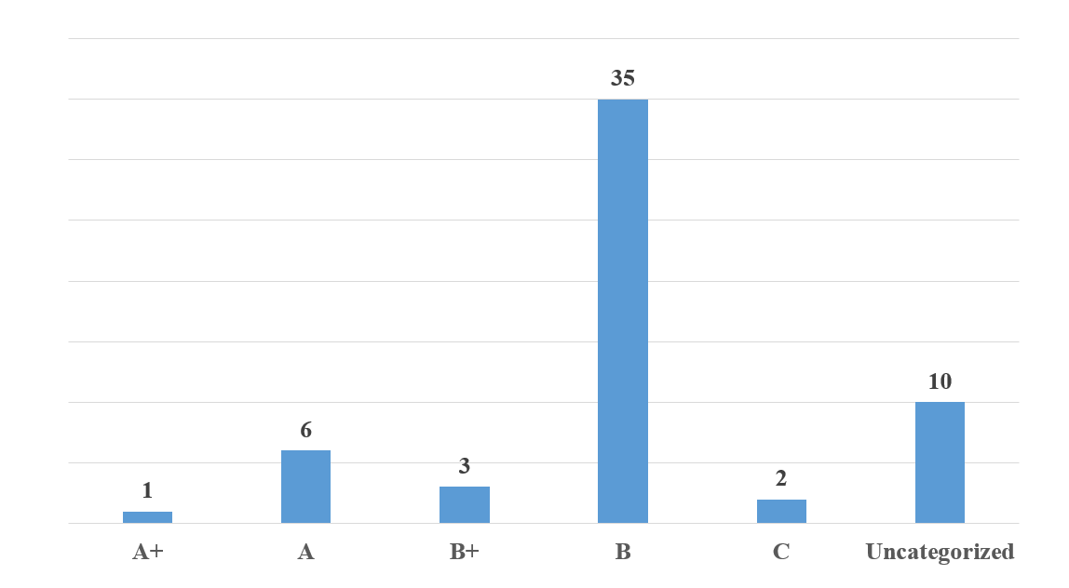Figure 1: Distribution of respondents by type of edited journal (n = 57)
Another group of 10 respondents (17.54%) indicated that they represent unaccredited journals. This notable proportion highlights the presence of a subset of journals operating outside the formal accreditation system, which may be in transition, emerging, or oriented towards unclassified thematic niches.
The remaining 66% of respondents (n = 37) are primarily affiliated with journals in categories B and C, which confirms the predominance of accredited, nationally recognized, or consolidating publications. As a general rule, these journals are indexed in institutional repositories and in the national database (the National Bibliometric Instrument – IBN), and occasionally in one or two international databases.
Questions regarding the scientific fields represented by the journals of the respondents offer valuable insights into thematic specialization, indicating the extent of fragmentation or convergence of disciplines within the local publishing landscape. The 57 respondents were given the opportunity to select multiple options, thereby reflecting the multidisciplinary orientation of numerous journals.
The data obtained indicate a clear dominance of fields within the socio-humanistic sphere, with educational sciences and legal sciences each receiving 14 mentions (24.56%). This is followed by sociology, history, and archaeology, which were mentioned 11 times (19.30%). Other frequently cited areas include philology, economics, arts, and culturology, each with 10 mentions (17.54%), as well as philosophy and medical sciences, which received 9 mentions (15.79%).
In contrast, the exact and applied sciences – such as chemistry and biology (n = 5; 8.77%), engineering sciences (n = 4; 7.02%), and physics and mathematics (n = 3; less than 6%) – are significantly less represented. Fields such as genomic sciences, military sciences, religion and theology, and information sciences were mentioned only marginally by one or two respondents.
An important aspect of this thematic distribution is the notable tendency toward inter- and multidisciplinarity. Only 15 respondents (26.3%) associated the journal they edited with a single scientific field, while the majority (n = 42; 73.7%) selected two or more areas. This orientation reflects a growing trend in scientific research that involves integrating knowledge and methods from multiple fields to address complex issues. This tendency is supported by recent literature that also addresses the challenges of evaluating and categorizing multidisciplinary journals (Zhang, et al., 2024; Redondo-Gómez, et al., 2024).

3.2. Compliance of Journals with International Publishing Standards and Existing Editorial Policies

Editors' perceptions regarding compliance with international citation rules and styles reflect a mixed, yet generally positive, outlook. According to the survey, 51.79% of respondents (n = 29) believe that these standards are partially met in their published articles, while 39.29% (n = 22) report full compliance. Only 5.36% (n = 3) indicate non-compliance, although they mention steps being taken to improve citation practices, and 3.57% (n = 2) did not express a clear position on the matter (Figure 2).

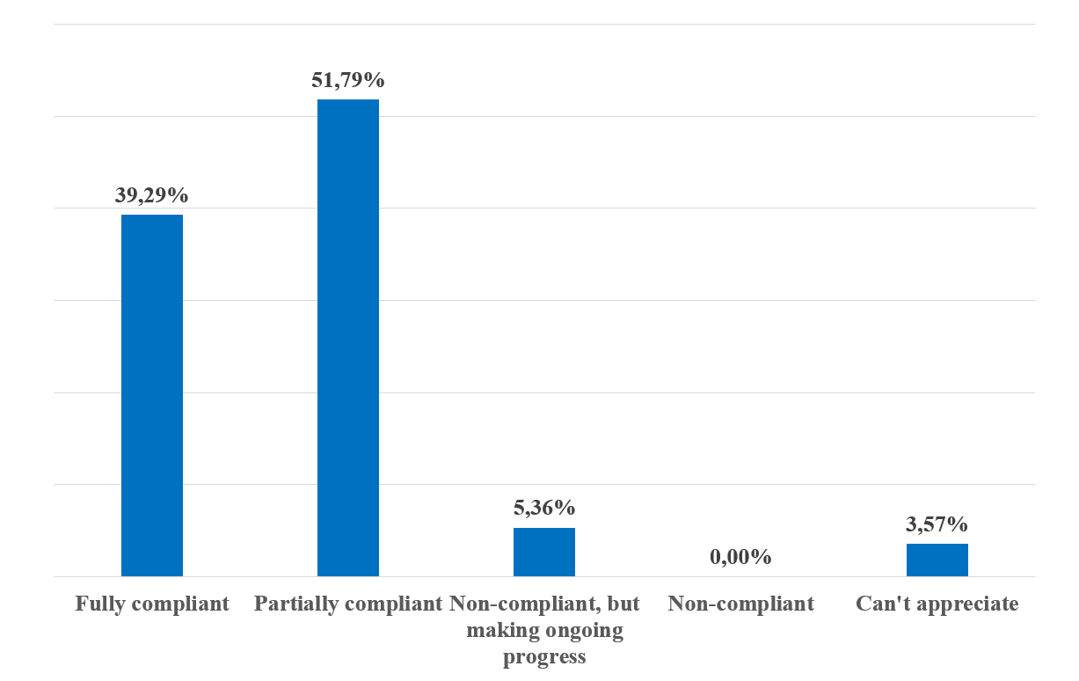Figure 2: Respondents' perspectives on adherence to international citation standards in journals
The editors' suggestions emphasize the necessity for a unified and professional approach. Common recommendations include: (1) developing a national citation guide that aligns with international standards (e.g., SM ISO 690:2022); (2) organizing training sessions for authors and editors; and (3) involving regulatory bodies, such as ANACEC, in establishing consistent guidelines. Additionally, it is proposed to implement a systematic mechanism for verifying references during the peer review process. Other suggestions include eliminating arbitrary editorial practices, promoting journals in international databases, and assisting authors in enhancing their academic writing and citation skills.
The results indicate a significant degree of heterogeneity in the application of citation styles, likely influenced by the specific characteristics of various scientific fields, the editorial experience accumulated over time, and the extent to which journals are integrated into international indexing systems. Publications seeking inclusion in major international databases, such as Scopus, WoS, and the DOAJ, appear to demonstrate greater adherence to international standards compared to those that are unaccredited or have low visibility.
Scholarly literature strongly supports the idea that adherence to international citation standards is essential for the professionalization of editorial practices. The rigorous application of these standards fosters trust in published content, facilitates the verifiability of sources, and enhances the impact and visibility of journals (Schniedermann, 2021; Khatoon, et al. 2024).
Inconsistent application of these standards, often scrutinized during indexing evaluations, undermines efforts to promote national journals internationally. While the indexing rate on the national IBN platform is notably high – 87.72% of respondents (n = 50) reported using this platform – the visibility at the international level is significantly lower (Figure 3). This distribution highlights the IBN's pivotal role as a national platform for archiving, performance evaluation, and access to scientific publications, in alignment with the national research framework.
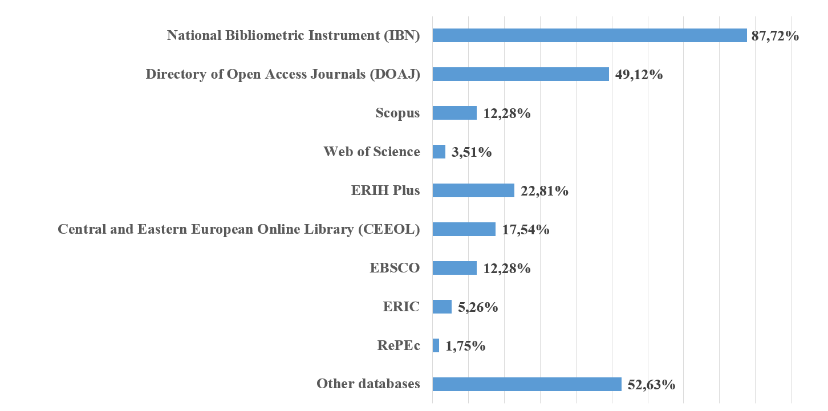Figure 3: Databases for respondents' edited journals (n = 57)
Of the international platforms, the DOAJ is cited by 49.12% of respondents (n = 28), indicating a significant interest in open access publishing and alignment with international standards of editorial transparency (Pölönen & Late, 2022; Fu et al., 2023). Other frequently reported databases include ERIH PLUS (n = 13; 22.81%), CEEOL (n = 10; 17.54%), and EBSCO (n = 7; 12.28%). Scopus is mentioned by the same number of respondents (n = 7; 12.28%), while Web of Science is referenced only marginally (n = 2; 3.51%), signalling limited integration into the most selective platforms.
This distribution may reflect the challenges faced by Moldovan journals in meeting the stringent criteria for editorial quality, scientific impact, and internationalization – issues that have also been emphasized in the literature (Chavarro et al., 2018).
However, a significant proportion of respondents (52.63%; n = 30) selected the option, indicating a variety of indexing strategies oriented towards thematic, regional, or aggregator databases. These included platforms such as Google Scholar, eLIBRARY.ru, Index Copernicus, AGRIS, BASE, WorldCat, CORE, and other open scholarly dissemination services. These alternative forms of indexing can enhance visibility within specialized scholarly communities or in linguistically and geographically diverse contexts, even if they do not always provide formal international recognition.

3.3. Editorial Policies of Journals: Levels of Formalization and Best Practices

According to national and international regulatory frameworks, the operation of a modern scientific journal necessitates transparent and well-documented editorial policies that govern various aspects, including the selection of content, the evaluation of scientific quality, the protection of authors’ rights, and publication ethics. The results of a survey conducted among publishers in the Republic of Moldova generally indicate alignment with these standards (Figure 4). Specifically, 98.21% of respondents (n = 55) confirmed the existence of policies that encompass journal objectives, author guidelines, ethical standards, and anti-plagiarism regulations.

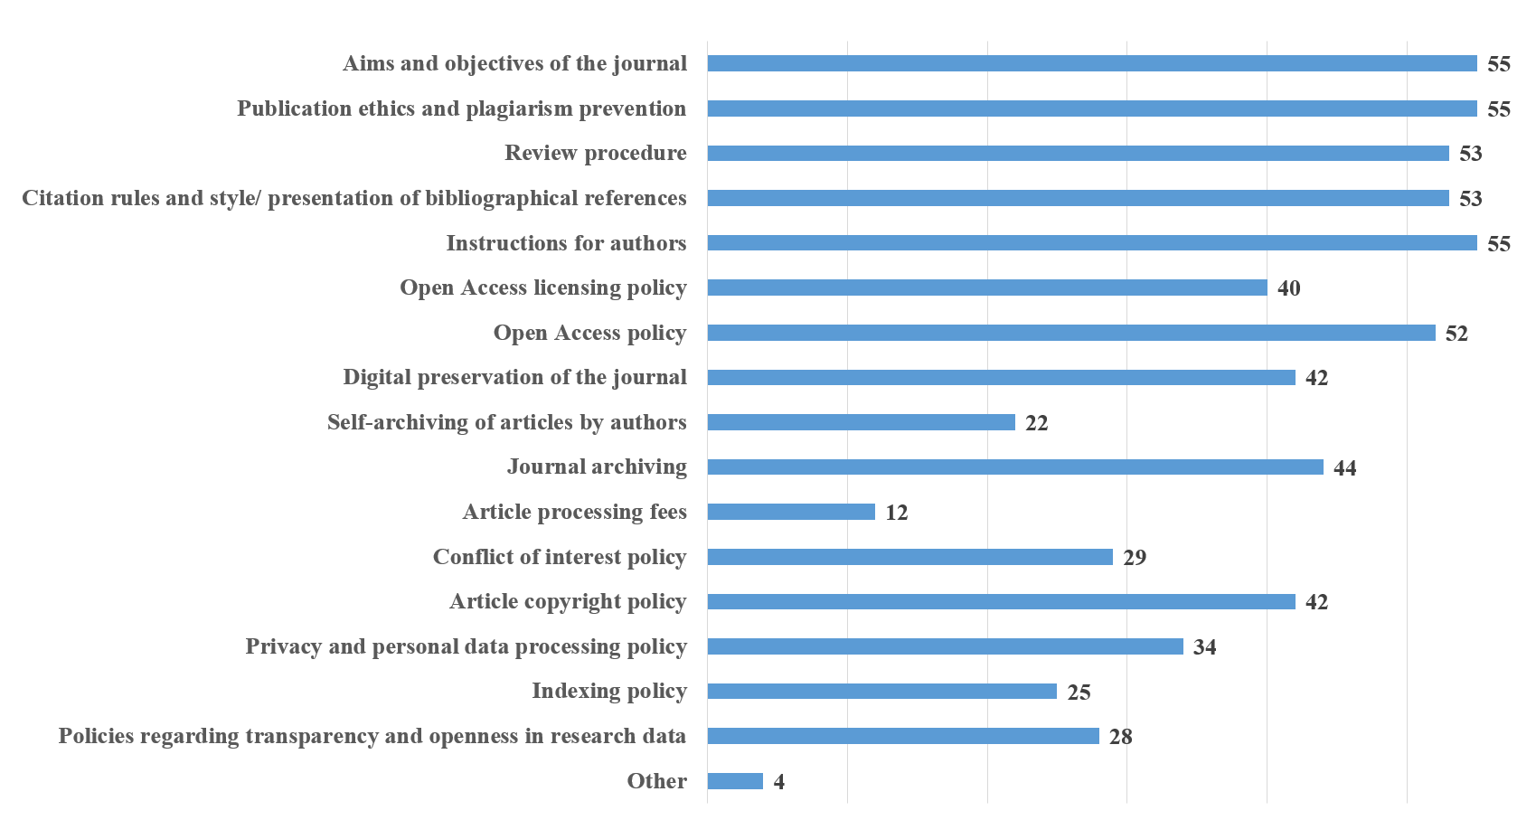Figure 4: Editorial policies regulated by journals (n = 56)
Also, 94.64% (n = 53) of respondents mentioned the peer review process and citation guidelines. Open Access policies are increasingly adopted, with 92.86% (n = 52) of participants reporting their implementation, while Open Access licensing is noted by 71.43% (n = 40). However, only 21.43% (n = 12) explicitly mention article processing fees in their editorial policies, while 39.29% (n = 22) report the existence of a self-archiving policy.
Key issues such as indexing (44.64%; n = 25), data transparency (50%; n = 28), and managing conflicts of interest (51.79%; n = 29) continue to be insufficiently integrated into formal editorial policies, limiting transparency and compliance with international standards. These findings highlight a publishing structure in transition, marked by significant advancements as well as gaps in policy implementation and technological capacity.

3.4. The Impact of Regulations on the Quality of Scientific Publications in the Republic of Moldova

The analyzed data indicate that national regulations have had a positive effect on the quality of scientific journals in the Republic of Moldova. A significant proportion of the surveyed publishers – 67.85% (n = 38) – perceived a high or very high influence of these regulations on the visibility of journals, while 21.43% (n = 12) considered that the regulatory framework contributed moderately to strengthening the presence of publications in the academic space (Figure 5).
This perception is further supported by the literature, which emphasizes that formalizing editorial requirements – including those related to ethics, structure, and the peer review process – can enhance the quality of published content and increase international visibility (Petrushka, 2022; McDonald et al., 2007).
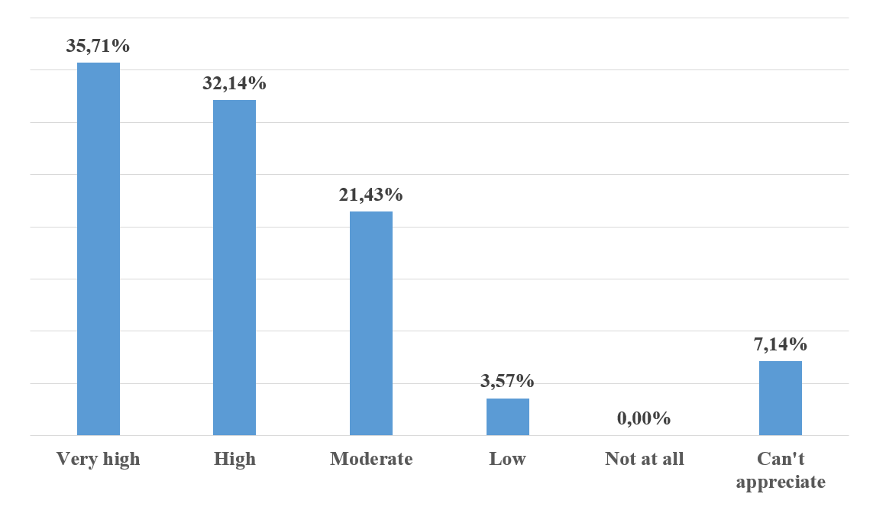Figure 5: Assessment of the impact of regulatory requirements on journal development (n = 56)
The data presented in Figure 6 indicate a predominantly favorable opinion among Moldovan publishers regarding the influence of formal requirements on the quality of scientific articles. Over 82% of the respondents (n = 27 for ‘very high’; n = 19 for ‘high’) believe that the mandatory inclusion of standard components – such as the abstract, keywords, introduction, methodology, results, conclusions, and references section – has resulted in a significant improvement in the quality of published papers.

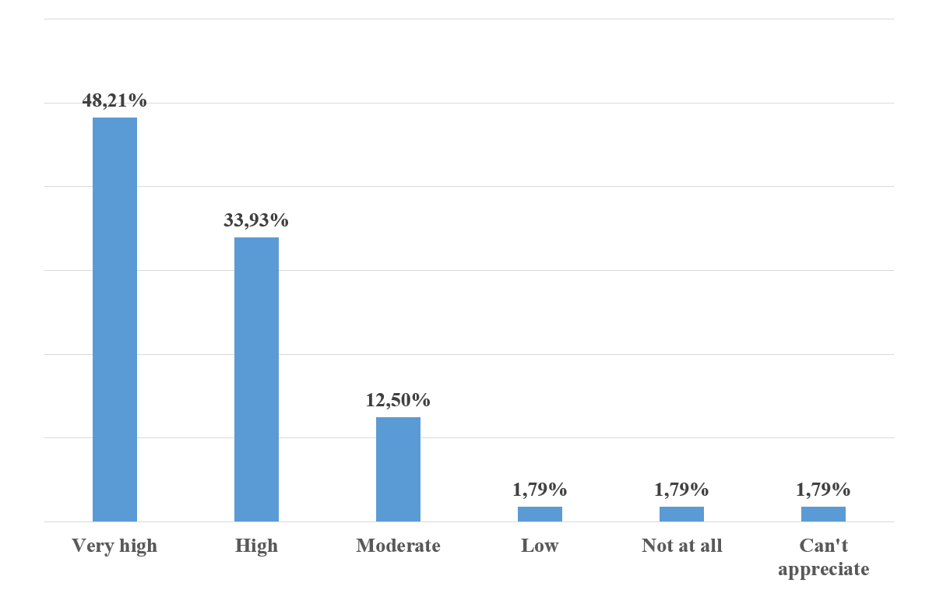Figure 6: Perceived impact of article structure requirements on publication quality (n = 56)

Only a small number of participants (n = 3 for each of the categories ‘low’, ‘not at all’, or ‘can't appreciate’) perceive a limited or negligible impact.
These results align with the existing literature, which emphasizes the crucial role of editorial policies and formal standards in enhancing the quality, visibility, and credibility of scholarly publications (Rozemblum et al., 2015; Bringula et al., 2023). In particular, in contexts where the publishing ecosystem is fragile or underfunded, such standards serve not only as obligations but also as benchmarks for professionalizing the publishing process (Petrushka, 2022; McDonald et al., 2007). Consistency in structure contributes to methodological transparency and enhances international visibility, a vital aspect for journals in non-English-speaking regions seeking recognition in a publishing landscape dominated by global entities (Nielsen-Muñoz et al., 2023).
Thus, the requirements for article structure – embedded in both national regulations and editorial policies – function as key mechanisms for the institutionalization of editorial practices. These requirements align publications with international standards and enhance the standing of Moldovan journals within global scientific networks.
The survey results indicate that the implementation of a review procedure involving at least two reviewers is perceived to have a significant impact on the quality and credibility of scientific journals in the Republic of Moldova (Figure 7). Specifically, 91.07% of respondents (n = 51) believe that this practice contributes ‘much’ or ‘very much’ to improving the quality of articles, while 87.5% (n = 41) highlight the role of peer review in enhancing the credibility of publications.

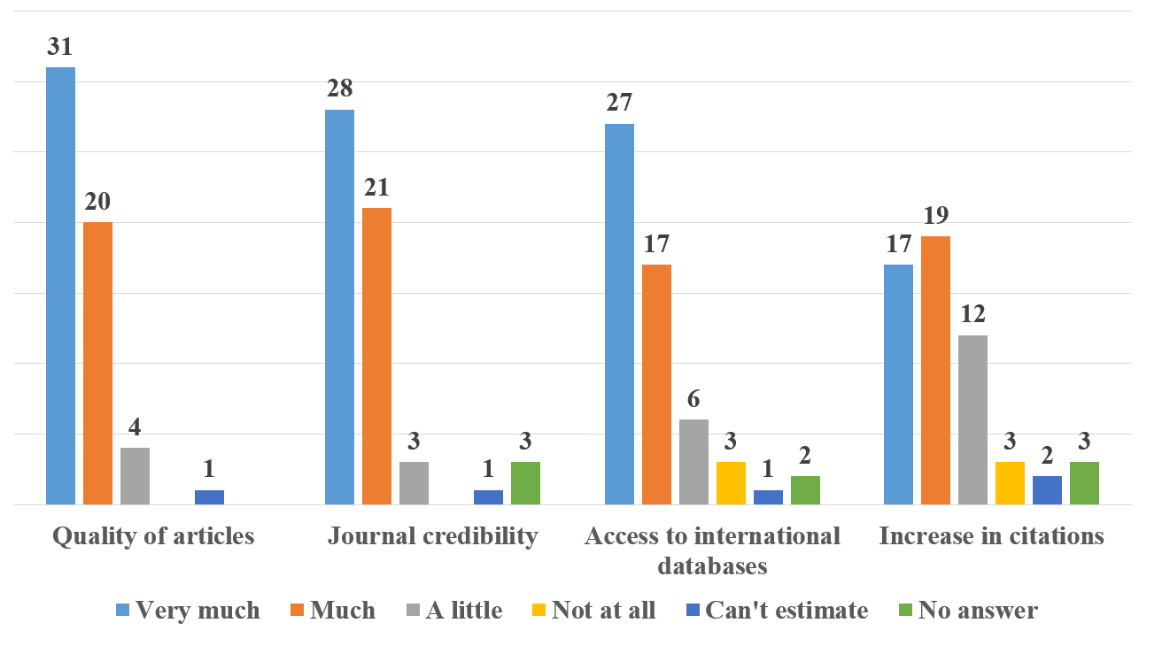Figure 7: Perception of the contribution of regulating and implementing peer review procedures
The qualitative comments reinforce these perceptions, highlighting the importance of the feedback provided by reviewers in clarifying arguments and strengthening methodologies. Peer review is universally acknowledged as a cornerstone of editorial quality, particularly in an environment where publications face the pressures of volume and rapid publication (Seeber 2024).
In addition, 78.57% of editors (n = 44) believe that the rigor of the review process has contributed to the accessibility of journals in international databases, thereby increasing their visibility and prestige. In contrast, the impact on the number of citations is considered more moderate (64.29%; n = 36), influenced by additional factors such as publication in English, the attraction of international reviewers, and the costs associated with indexing.
The survey also revealed several challenges. Some editors expressed concerns about the formalism of certain reviews, the lack of engagement from some reviewers, and the difficulty in identifying local experts. This often results in a reliance on foreign specialists. These issues underscore the necessity for honest and constructive reviewing that prioritizes content improvement rather than merely fulfilling procedural requirements.
Survey data indicate that editorial regulations are perceived to play a crucial role in enhancing the visibility of scientific journals in the Republic of Moldova (Figure 8). The study's results reveal that a significant proportion of respondents (71.43%, n = 40) believe these requirements have positively impacted the development of publications. Twenty-three respondents rated the influence as ‘high’ and seventeen as ‘very high’.

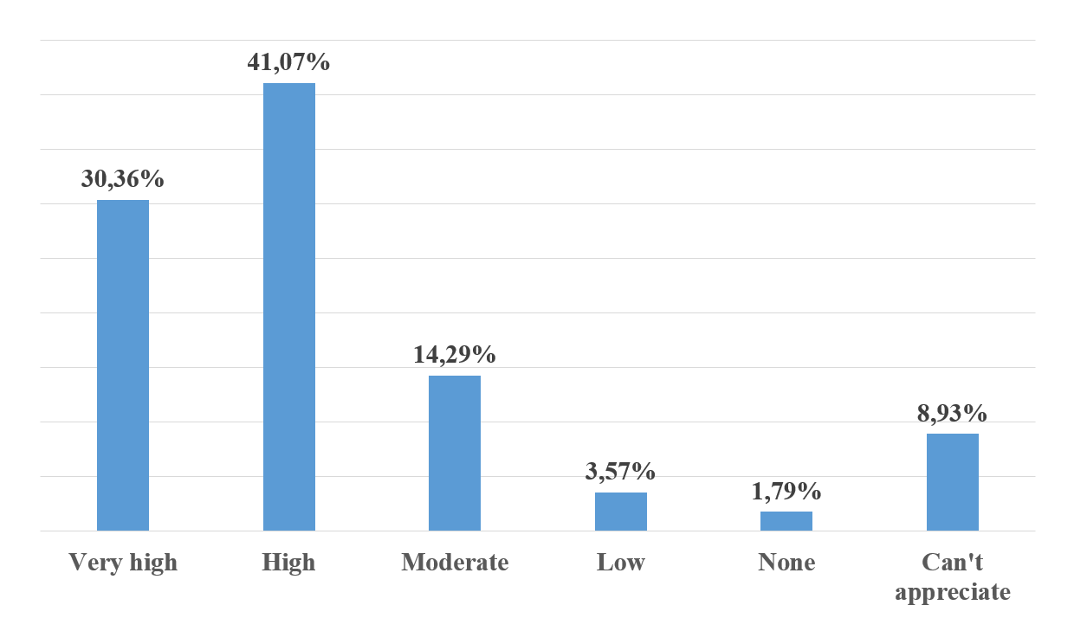Figure 8: Perception of the impact of regulations on journal visibility (n = 56)
The findings emphasize the pivotal role of standardizing article structure, adhering to international citation guidelines, and formalizing the review process in enhancing the reputation of journals within the regional scientific community. The existing literature supports this conclusion, highlighting that clear and transparent regulations contribute to the professionalization of editorial practices and facilitate integration into the global scholarly publishing landscape (Petrushka, 2022; Seeber, 2024).

3.5. Challenges and Strategies in the Indexing and Internationalization Process

The survey results indicate a nuanced but generally favorable assessment of international indexing requirements related to the indexing of scientific journals. Mean scores (on a scale of 1 to 4) highlight editorial priorities concerning global quality standards (Table 1).
The most appreciated aspects include the use of ORCID identifiers for authors (3.77), publication in internationally recognized languages with English abstracts and keywords (3.87), and DOI assignment for articles (3.64). These results indicate a strong awareness of the importance of persistent author identification and long-term discoverability of articles.
Criteria such as editorial policies aligned with international standards (3.59), the presence of an up-to-date website (3.59), compliance with regular publication schedules (3.47), and digital preservation (3.45) are also highly rated. This reflects ongoing efforts to modernize digital infrastructure and standardize editorial processes.
In contrast, criteria related to the internationalization of authors (3.04), the editorial board (3.18), and the use of OJS platforms (3.13) receive lower scores. This suggests significant challenges in attracting contributors from outside the country and in adopting advanced technologies – challenges frequently cited in editors’ open-ended responses.
Survey data indicate that editors in the Republic of Moldova are implementing a range of measures to enhance the international visibility of their journals.

Table 1: Publishers' perception of compliance with international indexing requirements
Requirements for compliance with international standards | Mean score
Content relevant to the subject area | 3.44
Peer review | 3.28
Ethical evaluation and anti-plagiarism | 3.38
A clear editorial policy that adheres to international standards | 3.59
International diversity of authors | 3.04
International diversity of the editorial board | 3.18
DOI identifier for the journal | 3.36
DOI identifier for each article | 3.64
ORCID identifier for each author | 3.77
Strict adherence to the declared periodicity | 3.47
Development of the journal website/webpage | 3.59
Development of the English version of the journal website | 3.27
Placement on the Open Journal Systems platform | 3.13
Complete and accurate bibliographic content | 3.43
Digital archiving and preservation | 3.45
Licensing and copyright | 3.23
Each article should clearly indicate its specific type of Creative Commons license | 3.04
Publishing abstracts and keywords in English | 3.87

Notes: (n = 56); 4-point scale (1 = not relevant, 2 = major challenge for the journal, 3 = difficult to implement but necessary, 4 = easy to follow and beneficial).

Among the most commonly employed strategies are the inclusion of abstracts in English and indexing in IBN, both cited by 91.07% of respondents (n = 51). This reflects a commitment to linguistic accessibility and national digital archiving. Additionally, a significant percentage of publishers support the adoption of ORCID identifiers and open access publishing (87.5%; n = 49), while 83.93% (n = 47) implement DOI identifiers for articles. These measures are essential for ensuring persistent linking, accurate citation tracking, and adherence to digital publishing protocols.
Other common practices include publishing in widely used international languages (82.14%; n = 46), adhering to international citation standards (80.36%; n = 45), creating digital archives (83.93%; n = 47), and enhancing the quality of reviews (78.57%; n = 44).
However, measures with significant potential, such as developing international partnerships (39.29%; n = 22) and promoting articles through professional translations (48.21%; n = 27), remain underutilized. This suggests the presence of limited institutional capacity and the absence of coordinated internationalization policies. The qualitative responses corroborate these findings, emphasizing the need for a more flexible and tailored approach for journals. This approach should not only prioritize indexing in established databases such as Scopus or WoS but also consider thematic and accessible platforms that are relevant to the respective fields.

3.6. Challenges and Strategies in the Indexing and Internationalization Process

The results of the survey highlight a range of systemic and operational obstacles that hinder compliance of scientific journals in the Republic of Moldova with current regulatory requirements (Table 2). The most frequently reported challenge is indexing in international databases such as WoS, Scopus, or DOAJ, mentioned by 55.36% of respondents. The challenges of indexing in international databases present a substantial barrier to the process of internationalization. This issue is supported by findings in the literature, which highlight the stringent requirements imposed by these platforms, as well as the additional pressures experienced by journals from peripheral scientific regions (Beigel, 2014; Seeber, 2024).
Another significant obstacle is the lack of a coherent national policy to support scholarly publishing, as indicated by 51.79% of participants. This leads to fragmentation in editorial efforts and hinders strategic coordination. Challenges associated with the costs of translating articles (50.00%) and attracting international authors (48.21%) further reduce the competitiveness of journals within the international scholarly community.
At the technical level, publishers report insufficient resources for adopting modern editorial management systems (44.64%) and adequate digital infrastructure (41.07%), as well as challenges in effectively organizing the peer-review process (41.07%). These findings align with existing literature, which underscores the difficulties faced during the digitization and professionalization of publishing (Smart, 2014; Zhao, 2017). Furthermore, the shortage of qualified staff, reported by 39.29% of respondents, underscores the urgent necessity for strategic investments in staff training.

Table 2: Perspectives on the challenges of complying with the requirements of the regulation
Obstacles to compliance with regulatory requirements | Responses
Obstacles to compliance with regulatory requirements | n | %
Insufficient financial resources to implement DOI identifiers for each article | 16 | 28.57%
Insufficient financial resources to adopt modern editorial platforms | 25 | 44.64%
High costs associated with translating articles into widely used international languages | 28 | 50.00%
Lack of essential technical infrastructure (e.g., Open Journal Systems – OJS, digital archiving) | 23 | 41.07%
Difficulties in implementing unique identifiers (DOI, ORCID) for articles and authors | 12 | 21.43%
Compatibility issues with international citation standards | 19 | 33.93%
Lack of qualified personnel to manage the editorial process | 22 | 39.29%
Difficulties organizing the peer-review procedure (e.g., identifying qualified reviewers, long evaluation times) | 23 | 41.07%
Insufficient number of article submissions | 12 | 21.43%
Difficulty maintaining publication periodicity in accordance with requirements | 14 | 25.00%
Challenges in indexing journals in international databases (e.g., WoS, Scopus, DOAJ, etc.) | 31 | 55.36%
Competition from other well-established national and international journals | 11 | 19.64%
Limited access to authors capable of submitting high-quality articles | 15 | 26.79%
Difficulties attracting international authors | 27 | 48.21%
Regulations perceived as overly complex or difficult to implement | 9 | 16.07%
Lack of a coherent national policy to support scientific journals | 29 | 51.79%
Requirement to be indexed in the National Bibliometric Instrument (IBN) | 3 | 5.36%
Other | 6 | 10.71%
Notes: (n = 56)

The publishers' responses reflect a clear consensus on the need to revise and adapt the Regulation on the evaluation, classification and monitoring of scientific journals, with the aim of making its provisions more applicable to the national context. Identified priorities include the establishment of mandatory institutional financial support for the operation of editorial teams, which encompasses editors, translators, and IT technicians, as well as logistical support for the publication process.
Publishers also advocate for the diversification, expansion, and updating of the list of recognized databases. DOAJ is often cited as a viable yet underutilized alternative indexing platform. Furthermore, there is a call for the elimination of bureaucratic requirements, such as the obligation to maintain printed documentation. Respondents emphasize the need to simplify evaluation processes and align them with international and European standards.
Respondents also emphasize the necessity of revising the classification criteria to accurately reflect the disciplinary specificity and status of generalist or humanities journals. It is proposed to extend the validity period of accreditation from four to five or six years, in accordance with international practices, to alleviate the administrative burden on editors.
In addition, specialized assistance is recommended to enhance indexing in international databases. Compliance with regulatory requirements, according to several publishers, should be accompanied by institutional incentives, including financial support, training opportunities, and dedicated promotion and digitization facilities.

3.7. Editorial Perspectives on the Future of Scientific Publications

Despite ongoing challenges, publishers' perceptions reflect a balanced optimism, influenced by clearly defined goals of modernization and internationalization. Approximately two-thirds of respondents expect improvements in article quality (64%, n = 32), enhanced international visibility (66%, n = 33), and the complete digitalization of editorial processes through the implementation of modern platforms such as OJS (66%, n = 33).
An equal proportion of respondents (66%) considers indexing in international databases to be a top priority, while nearly the same percentage (64%) anticipates an increase in the number of international contributors and enhanced financial support for editorial activities. Other identified measures include promoting open access and strengthening international collaborations, both of which received support from 62% of respondents (n = 31). Additionally, 46% of respondents (n = 23) highlighted the gradual integration of artificial intelligence into the editorial workflow as a significant measure.
However, more than 44% of respondents (n = 22) identified significant risks associated with insufficient financial resources and a lack of qualified personnel. Additionally, one-quarter (26%, n = 13) anticipate a potential reduction in the number of journals, driven by heightened competition and stricter regulatory requirements.
Qualitative comments highlight the necessity of training a new generation of editors, the significance of strategic state intervention, the expansion of international partnerships, and the strategic consolidation of journals as platforms for scholarly excellence. Simultaneously, respondents caution that these positive developments could be significantly undermined in the absence of structural reforms and coherent policy frameworks.
At the conclusion of the questionnaire, respondents were invited to express their opinions on the initiatives or policies necessary to foster the development of scientific publications in the Republic of Moldova. The editors' responses indicate a widespread belief that the progress of scientific journals in Moldova is impeded by a systemic lack of resources, the absence of a cohesive national strategy, and rigid regulations that are poorly adapted to local academic realities. At the same time, the suggestions provided are detailed and constructive, demonstrating a high level of professional engagement.
The most frequently suggested measures include:
• establishing dedicated grants for scientific journals;
• modernizing the digital editorial infrastructure;
• revising the criteria for classification and indexing;
• encouraging participation in international networks;
• professionalizing editorial work, including through appropriate compensation.

Editors emphasize that meaningful reform in the editorial field cannot occur without the allocation of sustainable financial resources, transparent and flexible policies, and formal recognition of the professional value of editorial work. There is an urgent need for a strategic vision that incorporates competitive funding, modern infrastructure, continuous training, and regulations tailored to both local conditions and international trends.

Conclusions
The study offers a comprehensive overview of the perceptions of scientific journal editors in the Republic of Moldova, indicating an editorial environment undergoing structural transformation and strategic adjustment. The data obtained confirm a clear orientation towards inter- and multidisciplinarity in scientific journals.
The implementation of regulatory provisions regarding article structure, peer review procedures, and journal promotion at both national and international levels has significantly enhanced article quality and journal visibility, particularly within the national context, as reported by 85.72% of respondents.
However, the implemented regulations have proven insufficient in enhancing the international visibility of journals. Just 12.28% of respondents reported indexing in Scopus, and 3.51% in WoS database.
Accessing relevant international databases is among the challenges most frequently cited by editors, with 55.36% of respondents identifying this issue. This is followed closely by the lack of a coherent national policy to support scientific journals, which was cited by 51.79% of respondents.
Editorial teams recognize the importance of enhancing international visibility and are implementing specific measures to achieve this goal. A significant 91.07% of teams report that they include detailed and relevant English abstracts for all articles and index them in the IBN, which serves as a resource for various international platforms. Furthermore, 87.5% of teams publish in Open Access, 82.14% publish articles in widely used international languages, 87.5% assign DOI identifiers, and 83.93% include authors' ORCID IDs. Additionally, 80.36% of editors report that they publish on open access platforms and adhere to international citation and bibliographic standards.
Despite recognizing their importance, editors often struggle to implement international standards, particularly in the areas of internationalization and technological modernization. These challenges arise not only from financial limitations but also from insufficient institutional support, inadequate infrastructure, and the marginal status of Moldovan journals within the global scientific community. This situation underscores the necessity for coherent policies specifically designed for the local context, ensuring not only regulatory compliance but also administrative, financial, and technological support for effective implementation.
Although the application of international citation norms and style is outlined in the majority of editorial policies (as reported by 94.64% of respondents), with only 39.29% of respondents affirming full compliance.
The inconsistent application of international citation and formatting standards poses a significant barrier to the inclusion of national journals in international databases. These deficiencies draw attention to an additional systemic weakness: the peer review process. Although most editorial policies assert that they implement peer review, the actual execution of this process remains questionable.
The study also highlights the structural challenges that editors encounter, including a shortage of qualified personnel, time constraints, limited access to technology, and difficulties in maintaining the integrity of the peer review process. These issues are further exacerbated by a lack of transparency and ambiguities in editorial communication. However, promising initiatives are emerging to professionalize editorial work, such as the adoption of international standards for ethics, transparency, and editorial independence. Digital technologies and artificial intelligence are viewed as opportunities, but they necessitate the establishment of clear regulatory policies.
Scientific publishing in the Republic of Moldova is currently undergoing institutional reconstruction, striving to achieve a balance between standardization and autonomy, as well as between international requirements and local realities. The findings of this study can serve as a foundation for developing more tailored editorial policies that promote a sustainable and competitive editorial system linked to global scientific networks. The challenges identified and the proposed solutions highlight a clear necessity: revising the regulatory framework through an integrated, contextualized, and financially supported approach that aligns with the realities and aspirations of Moldova’s scientific publishing ecosystem.

Acknowledgements
This work was supported by the grant from the National Agency for Research and Development of the Republic of Moldova 24.80012.0807.17SE ‘Trends in the development of the scientific publishing system in the Republic of Moldova through the lens of science policies (2008-2024)’.
The authors contributed equally to this article.

References
Anonymous. (2023) Integrarea socială a persoanelor cu dizabilități și susținerea acestora în procesul de informare prin intermediul bibliotecilor: license thesis. Bucharest: University of Bucharest.

Armato, S. (2016) ‘The Business of Scientific Publishing’, Journal of Applied Clinical Medical Physics, 17(1), 1-3, available: https://doi.org/10.1120/jacmp.v17i1.6239
Armstrong, J. S. (1982) ‘Research on Scientific Journals: Implications for Editors and Authors’, Journal of Forecasting, 1(1), 83-104, available: https://doi.org/10.1002/for.3980010109
Beigel, F. (2014) ‘Introduction: Current tensions and trends in the World Scientific System’, Current Sociology, 62(5), 617-625, available: https://doi.org/10.1177/0011392114548640
Bringula, R. P. et al. (2023) Predicting Suspected Predatory Open Access Computing Journals: An Analysis of Editorial Compliance, Publishing Efficiency, and Bibliometric Services, in NLPIR '23: Proceedings of the 2023 7th International Conference on Natural Language Processing and Information Retrieval. New York: Association for Computing Machinery, pp. 266-272, available: https://doi.org/10.1145/3639233.3639254
Chavarro, D., Ràfols, I. and Tang, P. (2018) ‘To what extent is inclusion in the Web of Science an indicator of journal ‘quality’?’, Research Evaluation, 27(2), 106-118, available: https://doi.org/10.1093/reseval/rvy001
Chowdhary, R. R. (2013). ‘Editorial. Changing Trends in Research Publication’, International Journal of Prosthodontics and Restorative Dentistry, 3(3), V, available: https://doi.org/10.5005/ijoprd-3-3-v
Cooperman, S. R. and Brandão, R. A. (2023) ‘AI Assistance with Scientific Writing: Possibilities, Pitfalls, and Ethical Considerations’, Journal of Foot & Ankle Surgery, 4(1), 100350, available: https://doi.org/10.1016/j.fastrc.2023.100350
Fernandes, T. L. do N. and Falcão, F. da S. (2021) ‘Editorial Production of Scientific Journals: The Influence of Technological Development on Scientific Certification, Editorial Management, and Post-publication’, in L. Pereira et al. (eds) Proceedings of IDEAS 2019. IDEAS 2018. Smart Innovation, Systems and Technologies. Springer: Cham, vol. 198, pp. 322-331, available: https://doi.org/10.1007/978-3-030-55374-6_32
Fu, W., Xu, J., Fang, Q., Ding, J. and Ma, H. (2023) ‘Going Open Access: The Attitudes and Actions of Scientific Journal Editors in China’, Publications, 12(1), 1, available: https://doi.org/10.3390/publications12010001
Garrido, I. L. (2023) ‘Artificial Intelligence and Academic Journals: For Better and for Worse’, BAR - Brazilian Administration Review, 20(4), e230145, available: https://doi.org/10.1590/1807-7692bar2023230145
Gomez, C. J. (2023) ‘The Growing Concentration of National Influence in Global Science and its Impact on Future Research’, OSFPreprints, 30 Jan, available: https://doi.org/10.31219/osf.io/5yt4r
Hanna, M. (2019) ‘Ethics of Scientific Publishing’, in M. Hanna How to Write Better Medical Papers. Cham: Springer, pp. 233–238, available: https://doi.org/10.1007/978-3-030-02955-5_46
Khatoon, A., Daud, A. and Amjad, T. (2024) ‘Categorization and correlational analysis of quality factors influencing citation’, Artificial Intelligence Review, 57, 70, available: https://doi.org/10.1007/s10462-023-10657-3
Kratochvíl, J., Plch, L. and Koriťáková, E. (2019) ‘Compliance with ethical rules for scientific publishing in biomedical Open Access journals indexed in Journal Citation Reports’, Vnitr̆ní Lékar̆ství, 65(5), 338–347, available: https://doi.org/10.36290/VNL.2019.061
Martens, K. (2008) ‘Editorial: the future of scientific publishing’, Hydrobiologia, 600(1), 1-2, available: https://doi.org/10.1007/S10750-008-9333-0
McDonald, J., Eisemann, M. and Cox, A. (2007) ‘A matter of trust: introducing the journal scientific integrity policy’, The American journal of pathology, 1711, 1, available: https://doi.org/10.2353/AJPATH.2007.070458
Molinié, A. and Bodenhausen, G. (2013) ‘On toxic effects of scientific journals’, Journal of Biosciences, 38, 189-199, available: https://doi.org/10.1007/s12038-013-9328-5
Nielsen-Muñoz, V., Azofeifa-Mora, A. B. and Monge-Nájera, J. (2023) ‘Seventy years of the Journal of Tropical Biology: historical trends by topic, authorship, country, and institution’, Revista De Biología Tropical, 71(S3), e57976, available: https://doi.org/10.15517/rev.biol.trop.v71iS3.57976
Papadopoulou, P. and Lytras, M. D. (2024) ‘Enhancing Scientific Rigor With Editorial Roles and AI’, in M. D. Lytras, P. Papadopoulou and S. Konstantinopoulou (eds) Advances in Medical Technologies and Clinical Practice Book Series. Hershey: IGI Global, pp. 39-62, available: https://doi.org/10.4018/979-8-3693-4422-4.ch003
Petrushka, A. (2022) ‘Editorial Policy of Scientific Journal as Factor in Ensuring Principles of Publication Ethics’, Bìblìotekoznavstvo, Dokumentoznavstvo, Ìnformologìâ, 4, 63-71, available: https://doi.org/10.32461/2409-9805.4.2022.269808
Pölönen, J. and Late, E. (2022) ‘How society publishers practice open science beyond open access publishing?’, in: D. Cupar and Z. Džoić (eds) PUBMET2022: The 9th Conference on Scholarly Communication in the Context of Open Science, pp. 32-33, available: https://doi.org/10.15291/pubmet.3930
Redondo-Gómez, D., Arroyo-Machado, W., Torres-Salinas, D., Margalida, A. and Moléon, M. (2024) ‘A long-term assessment of the multidisciplinary degree of multidisciplinary journals’, PLOS ONE, 19(12), e0314616, available: https://doi.org/10.1371/journal.pone.0314616
Rozemblum, C., Unzurrunzaga, C., Banzato, G. and Pucacco, C. (2015) ‘Calidad editorial y calidad científica en los parámetros para inclusión de revistas científicas en bases de datos en Acceso Abierto y comerciales’, Palabra Clave [La Plata], 4(2), 64-80, available: https://www.palabraclave.fahce.unlp.edu.ar/article/download/PCv4n2a01/6597 [Accessed: 5 Apr 2025]
Schniedermann, A. (2021) ‘A comparison of systematic reviews and guideline-based systematic reviews in medical studies’, Scientometrics, 126(12,) 9829-9846, available: https://doi.org/10.1007/s11192-021-04199-0
Seeber, M. (2024) ‘Changes in scientific publishing and possible impact on authors’ choice of journals’, ChemTexts, 10(3), 5, available: https://doi.org/10.1007/s40828-024-00190-3
Shah, P. S. and Acharya, G. (2024) ‘Artificial intelligence/machine learning and journalology: Challenges and opportunities’, Acta Obstetricia et Gynecologica Scandinavica, 103(2), 196-198, available: https://doi.org/10.1111/aogs.14772
Smart, P. (2014) ‘The big picture: scholarly publishing trends 2014’, Science Editing, 1(2), 52-57, available: https://doi.org/10.6087/KCSE.2014.1.52
Smith, G. (2000) ‘Scientific journals with editorial independence: an endangered species?’, Current Opinion in Anaesthesiology, 13(2), 187-190, available: https://doi.org/10.1097/00001503-200004000-00018
Tabatadze, B. (2024) ‘Prospects of Using AI Technologies in Open Journal Systems (OJS)’, Journal of Technical Science and Technologies, 8(2), 68-74, available: https://doi.org/10.31578/jtst.v8i2.163
Toth, L., Compton, S. and Tolwani, R. (2009) ‘Competing interests policy for AALAS journals’, Comparative medicine, 59(3), 249-250, available: https://pmc.ncbi.nlm.nih.gov/articles/PMC2696825/ [Accessed: 5 Apr 2025]
Young, G. (2009) ‘Psychology Journals: Proposal for Financial Disclosure Policies’, Psychological Injury and Law, 2, 143-148. https://doi.org/10.1007/S12207-009-9048-1
Zarif, A. (2023) ‘The Economics of Scientific Publishing’, The Yale Journal of Biology and Medicine, 96(2), 267-273, available: https://doi.org/10.59249/OMSP9618
Zhang, J., Yang, L. and Shen, Z. (2024) ‘Analyzing Journal Category Assignment Using a Paper-level Classification System: Multidisciplinary Sciences Journals’, Scientometrics, 129(10), 5963-5978, available: https://doi.org/10.48550/arXiv.2305.02530
Zhang, M. and Charbonneau, D. H. (2024) ‘Artificial intelligence (AI) and scholarly publishing ethics: A content analysis of journal policies’, in ALISE Proceedings of the Association for Library and Information Science Education Annual Conference, Portland, pp. 1-2, available: https://doi.org/10.21900/j.alise.2024.1718
Zhao, L. (2016) ‘Application of Network Technology in Sci-tech Journal Editing and Publishing Process’, in ICIMM 2016. Proceedings of the 6th International Conference on Information Engineering for Mechanics and Materials, Atlantis Press, pp. 696–699, available: https://doi.org/10.2991/ICIMM-16.2016.124
Zhao, L. (2017) ‘Application of Modern Information Technology in Sci-tech Journal Editing and Publishing Process’, in ICEISS 2017 Proceedings of the International Conference on Education Innovation and Social Science (ICEISS 2017), Atlantis Press, pp. 61–64, available: https://doi.org/10.2991/ICEISS-17.2017.15
Zhenchenko, M., Izarova, I. and Kharlamova, G. (2024) ‘Editorial Policy and Publication Ethics of the Series of Scientific Journals “Bulletin of Taras Shevchenko National University of Kyiv”. Kyiv: Київський університет, available: https://doi.org/10.17721/edit.policy.2024

