Accessibility of Romanian county libraries for people with disabilities

Dana Zaharia
Bucharest University, Faculty of Letters, Information Management in Present Society Master’s degree programme
Email dana.zaharia@litere.unibuc.ro

Abstract:
The paper aims to draw attention to the right of access to information, emphasizing the need for accessibility, adaptation of services and products offered by public institutions and strengthening the process of social integration of people with disabilities. To this end, we will investigate the level of accessibility of Romanian county libraries for people with disabilities, following three perspectives: accessibility of county libraries in terms of products, services and spaces; accessibility of library sites; visibility of information of interest, specific to the needs of people with disabilities. The conclusions of the paper will provide a picture of the current state of accessibility at the level of the largest public libraries in our country, being a landmark for optimizing the activity of county libraries (and not only).

Keywords: people with disabilities, accessibility, county libraries, Romania, library sites

1. Introduction
This paper addresses the topic of access to information for people with disabilities by making libraries accessible, focusing on the public type library, which addresses the needs and requirements of all categories of users. Access to information is a fundamental right in today's society, which must not be restricted by social, economic or other causes.
Carrying out a research paper on this subject, which aims to create an overview of the accessibility of public libraries (in the case of this research, the Romanian county libraries) can contribute to promoting the idea of equalization of chances and raising awareness of the need for libraries to be accessible for all categories of libraries users. In addition, the results of the research we have undertaken can be a guide for optimizing the accessibility of county libraries and not only.
In order to create a more extensive image of the accessibility level of the county libraries, we started from the question ,,What is the level of accessibility of the county libraries in Romania from the perspective of the three types of environment (physical, informational and communicational)?”. In the analysis of these aspects, three directions of investigation were followed: the level of accessibility of libraries (from the perspective of accessible documents, access technologies, physical space, personnel, etc.), the accessibility of library sites and the visibility of information of interest to users with disabilities, having a significant role in promoting library services specific to their needs.
This research is a mixed-type research, using various data collection tools and methods to broaden the research horizon and minimize the subjectivity of the analysis.
The main purpose of the paper is to contribute to the awareness of the impact that libraries have in community life, of the possibilities to improve the quality of life of people with disabilities both on a personal level, as well as professionally, through information – the most precious asset of contemporary society.
This research aims to promote the concept of access for all, to motivate the need to implement library services specific to this category of users, to provide a landmark in optimizing the activity of libraries in the country and to contribute to the development of the subject of people with disabilities in libraries, which is one not so often addressed in the Romanian specialized literature.

2. Accessibility of Romanian county libraries for people with disabilities

1.1 The general framework

County libraries, which can be considered the largest public libraries in our country, have a decisive role in the users’ information and documentation process. They have directed their products and services to a wide audience, to an entire community. Thus, users which belong to various categories, will have different needs and requests. One of the categories targeted is that of users with disabilities, libraries being obliged to adapt their facilities to ensure effective information for users, but also to support social inclusion.
This study follows the level of accessibility of Romanian county libraries for people with disabilities, these libraries being representative through the diversity of users, their occupations and interests. The target subjects of the study are directed to: the level of accessibility of library collections and services provided, supporting the information process with the help of specific modern technologies, easy and quick access to library spaces, but also the technological skills of librarians for the purpose of assisting and training disabled users. In Romania, there are 40 county libraries, plus the Metropolitan Library of Bucharest, which plays the role of county library for Ilfov County. Thus, the study covers 41 libraries, but focuses on the analysis of only 31 of them, as only those provided the necessary information at the time of their request. The libraries for which we will analyse the level of accessibility for people with disabilities are the Metropolitan Library of Bucharest and the libraries in the counties: Argeș, Bacău, Bihor, Botoșani, Brașov, Brăila, Buzău, Caraș-Severin, Cluj, Constanța, Dolj, Galați, Giurgiu, Gorj, Harghita, Ialomița, Iași, Maramureș, Neamț, Olt, Prahova, Satu Mare, Sălaj, Sibiu, Suceava, Teleorman, Tulcea, Vâlcea, Vrancea.

1.2. Applied methodology

As a method of data collection, the questionnaire was used, consisting of a total of 13 questions whose number could vary depending on the answers provided by the respondents. Only one response was required from each institution (response regarding the whole institution, not at branch level). The collecting of replies was carried out on 27 March 2023 – 28 April 2023.
The first three questions refer to collections of documents accessible to people with disabilities. Questions 4-7 concern access technologies and librarians responsible for training people for their use. Questions 8 and 9 address the level of physical accessibility of the library. Question 10 concerns the level of use of the library by disabled users. Questions 11 and 12 capture the level of accessibility of library sites and, respectively, the level of promotion of services and information of interest for people with disabilities (these two questions will be addressed and analysed in the next chapter). The last question has as reason the identification of the library (for a good management of the answers). The responses provided by the libraries will remain anonymous, being analysed and interpreted only for statistical purposes.
Most of the questions were followed by explanations or examples to eliminate misunderstandings, ambiguities or problems caused by misunderstanding of a specialized language.

1.3 Research results

On the first question, „Do library collections contain documents in formats accessible to users with disabilities?” two libraries replied „they do not have this type of documents”, 19 that they have this type of documents in a „low number”, and 10 libraries that have these documents „in a sufficient number for the needs of specific users”. No library responded that it would have documents in formats accessible to people with disabilities in a „large number”. Thus, the majority of libraries, precisely 68%, cannot support at an optimal level the information process of disabled users due to an irrelevant number of documents accessible to their needs or even the lack of them. Only 32% of libraries can meet the information needs of people with disabilities. From the fact that no library has a large collection of documents addressed to people with disabilities, we can deduce that there was no interest in this purpose, although this need is obvious, especially in the case of libraries that (according to the statistical report made by the National Authority for the Protection of the Rights of People with Disabilities, 2022) serve counties that are in the top as the number of people with disabilities, but which replied to this questionnaire that the accessible documents are in their collections in a low number.
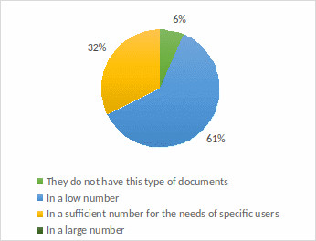
Figure 1. Answers to question one - Do the library collections contain documents in formats accessible to disabled users?
On the second question, „For what categories of disabilities does the library have in its collections documents in accessible formats?”, the libraries (except for the two that do not have this type of documents) answered as it follows: 16 libraries have only documents for the visually impaired people, a single library has documents only for people with motor impairments, 4 libraries have for visual and auditory problems, 3 libraries for visual and motor problems, a library has documents for hearing and motor deficiencies, and 4 libraries have documents specific to the three categories of disabilities. No library replied that it had documents for other categories of deficiencies. Thus, documents specific to the needs of people with visual impairments can be found in 27 libraries, and for people with hearing impairments or motor deficiencies in nine libraries. The focus is more on documents for visually impaired people because people with auditory or motor impairments have greater autonomy in using conventional formats, while people with visual impairments depend on alternative formats in the absence of access technologies.
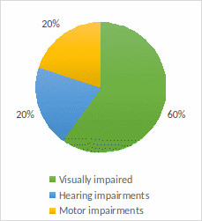
Figure 2. Answers to question 2 - For what categories of disabilities does the library have in its collections documents in accessible formats?
On the third question, „What are the ways of acquiring or procuring documents for disabled users practiced by the library?”, the libraries answered as follows: 11 libraries practiced buying only by purchasing, 4 Libraries obtained documents in formats accessible only from donations, 7 libraries have developed their collection of documents accessible both by purchase and by donations, and 6 libraries practice purchasing through buying and donations, but they also resort to interlibrary loan. Thus, buying by purchase is the most used, being a common practice of 24 libraries, followed by receiving donations in the case of 17 libraries. Interlibrary loan is less often made, in this research only by 6 libraries, as it is customary, where possible, that the user is directed to another institution in the county that is intended for these users and that can meet their information needs. A single library chose the answer option „other”, but from the open answer that was offered by the respondent, it could be inferred that they did not understand the question asked, so we will not consider the answer.
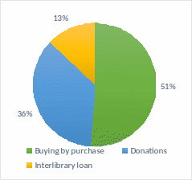
Figure 3. Answers to question 3 - What are the ways to purchase or obtain documents for disabled users practiced by the library?
On the fourth question, „Does the library provide disabled users with assistive/access technologies?”, 21 libraries replied that they make such technologies available to users, and the remaining 10 libraries replied that they do not have access technologies. Therefore, most of the libraries analysed, at a rate of 68%, can support user access to information, efficient and fast development of information and documentation processes, and, reading of printed documents (through the intermediation offered by technologies), as well as of electronic resources, until browsing the internet, thus supporting the autonomy of users in carrying out these activities.
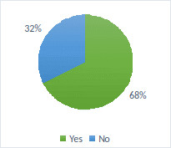
Figure 4. Answers to question 4 - Does the library provide disabled users with assistive/access technologies?
Comparing the results obtained on the first question with those on question 4, we will notice that: of the libraries that replied that they hold documents in accessible formats „in sufficient number for specific users' needs”, 8 libraries also offer access technologies, and two, do not; of the libraries that contain in their collections a „low number” of documents in accessible formats, 12 offer access technologies instead, and the remaining 7 do not own them; of the two libraries that do not provide documents specific to users with disabilities, one library does not offer any assistive technologies, and the other offers at least the ones supporting the information process of users. Thus, most libraries containing documents in accessible formats are prone to provide users with assistive technologies in order to be able provide the ability to inform multiple categories of users, through a variety of ways, depending on their specific needs and preferences.
At question number 5, „For what categories of disabilities does the library provide users with assistive/access technologies?”, of the libraries that have this type of technology: 11 have access technologies specific only to users with visual impairments, 3 have technologies for those with visual and hearing impairments, 2 for those with visual and motor impairments, a single library for those with hearing and motor impairments, and 4 libraries offer specific technologies to all three categories of disabilities. No library has responded that it has assistive technologies addressed to other categories of people with disabilities. Thus, the assistive technologies specific to people with visual impairments can be found in 20 libraries, those for people with hearing impairments in 8 libraries and those for people with motor impairments in 7 libraries.
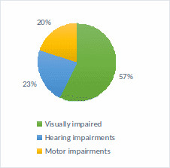
Figure 5. Answers to question 5 - For which categories of disabilities does the library provide users with assistive/access technologies?
As with documents in accessible formats, access technologies for people with visual defects are of greater interest, and if, in the case of documents for the hearing impaired and the motor disabled, the number of libraries offering such documents was now equal, in the case of access technologies specific to these disabilities, the number of libraries that make the technologies available to them, does not differ much.
On the sixth question, „Is there at least one librarian inside the institution who knows how to use assistive technologies and who can provide training in this regard?”, 12 libraries had a negative answer, 5 libraries said that there is a librarian in the institution who has specific responsibilities in this regard, and 4 libraries claimed that there is more than one librarian who possesses this type of knowledge and who can handle providing such services. The fact that more than half of libraries (57%) they do not have specialized personnel for the access technologies they make available to people with disabilities, is a worrying one ,and can create barriers to the information process of uninitiated users in using these technologies or those who are experiencing problems.
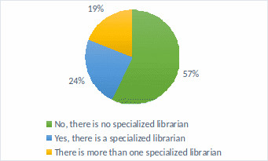
Figure 6. Answers to question 6 - Is there at least one librarian inside the institution who knows how to use assistive technologies and who can provide training in this regard?
At question number 7, „What are the ways of purchasing or acquiring assistive technologies for users with disabilities practiced by the library?”, 13 libraries provided the answer acquiring by purchase, 3 libraries replied that they obtained them only from donations, and 5 libraries own these technologies using both methods. No library has specified any other way of procuring these technologies. Therefore, most libraries need to rely on their own resources to be able to integrate such technologies into the products offered by the library.
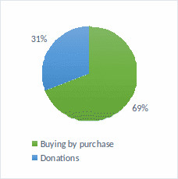
Figure 7. Answers to question 7 - What are the ways to purchase or acquire assistive technologies for users with disabilities practiced by the library?
At question number 8, „Entrances in the library premises are accessible to people with disabilities?”, 2 libraries submitted a negative answer, 6 claimed that they are partially accessible and 23 libraries affirmed the total accessibility of entries. Thus, the majority of libraries, 74%, meet the first necessary condition in providing access for people with disabilities to the facilities offered by libraries to citizens. The remaining libraries that have problems providing physical access, by limiting certain entries, by impossibility, diminishes, or hinders the information process of disabled users or their participation in cultural and educational activities organized within the library.
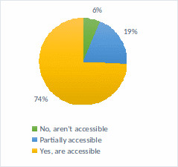
Figure 8. Answers to question 8 - Are the entries inside the library accessible to people with disabilities?
On the ninth question, „Is the library architecturally accessible regarding design – spaces, furniture and orientation in the library?, 10 of the libraries have admitted the inaccessibility of library space, and 12 replied that the library is partially accessible and 9 claimed that the library space is totally accessible. The problem of accessibility of spaces is obvious and makes it difficult to carry out library-specific activities in providing information and documentation services for disabled users and at the same time, it prevents the institution from fulfilling its mission as a social institution.
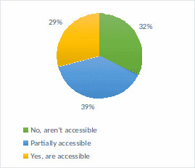
Figure 9. Answers to question 9 - Is the library architecturally and design accessible regarding – spaces, furniture and orientation in the library?
All libraries which have responded that they have average or serious problems related to the physical accessibility (of library entrances and/or spaces), and questions 1 and 4 were answered in the affirmative to the possession of documents in accessible formats and access technologies. Naturally, questions arise regarding the possibility of providing services to people with disabilities in these conditions and their quality level.
At question number 10, „Do disabled people visit the library and benefit from its services?”, 5 libraries replied that people with disabilities are not among the library users, 20 libraries mentioned the existence of these users, but in a low number and 6 libraries called disabled users active users of the library.
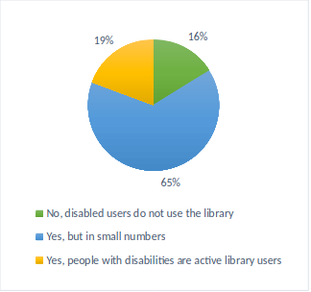
Figure 10. Answers to question 10 - Do people with disabilities attend the library and benefit from its services?
In case of libraries that responded „No, disabled users do not attend the library”, this situation can be easily motivated by the limited number of documents in accessible formats, the lack of access technologies, etc., limited or almost impossible access to library entries and spaces, lack of specialized personnel to communicate with disabled users and their training (all resulting from previous responses). Just as the response given by libraries that claimed that „people with disabilities are among the active users of the library” is motivated by offering all or a part of these optimal conditions for creating and maintaining an institution accessible to all categories of users.
Less than half of the libraries that responded that they are frequented by disabled users, but in a low number, partially comply with the conditions necessary to provide easy services. Even in the case of a library, the answers of which are inferred to provide full accessibility from all the perspectives addressed in the questionnaire, the number of users requesting its services is limited. In these situations, the causes and ways in which they can be neutralised must be found, whether they relate to the level of accessibility of the three media (physical, informational and communicative) or are indirect problems, but which can substantially influence the relationship of the library with the disabled users (a possible cause may be the lack of promotion of the products and services offered).

2. The websites of the county libraries in Romania - accessibility and informational support for disabled users

2.1. General framework

Another important space for users of a library is the website. The library's website is essential for remote access and use of the institution's products and services, but also for access to all information of interest; it has both an informative role, as well as an advertising one. Accessibility of the site for all categories of users must become a priority objective of the library, only thus being able to promote its facilities on a large scale and attract new users. Some special services, offered by a limited number of libraries, will lose their usefulness if they are not known, the target people being not informed of the possibilities offered by the library and thus, unable to benefit from them.
In this research, we will follow these two dimensions of accessibility: the accessibility of the websites of the county libraries in Romania and the visibility of the information of interest, specific for the needs of people with disabilities, available on library websites.
For the present study we do not depend on the information provided by libraries directly (as in the case of the first case study, which had as a way of collecting data, the questionnaire), but we have the possibility to evaluate all the county libraries in Romania through their public websites and the information contained therein. Thus, this research is applied to the entire group of the 41 county libraries.

2.2. Applied methodology

For the collection of the data necessary for the analysis of the websites of the county libraries, we will use two tools to evaluate the accessibility of the web pages: WAVE (Web Accessibility Evaluation Tool) and Website Accessibility Health Score (Web Accessibility by Level Access). With their help, we will analyse a single web page of each site, but the most relevant - the main page or „Home” page. Since library sites are constantly active, subject to continuous changes, the results of web page evaluation may differ from day to day, but the probability of substantial changes occurring in a short period is low. These two tools follow complying the rules and recommendations presented in the Web Content Accessibility Guidelines. The evaluation carried out using the WAVE tool took place on 29 April 2023, and the evaluation prepared with the Website Accessibility Health Score tool on 3 May 2023.
According to the information on wave.webaim.org page, WAVE is developed and made available free of charge by Web AIM, part of the Centre for People with Disabilities at Utah State University. WAVE is a web page accessibility assessment tool that plays a key role in capturing web design and construction mistakes that hinder people with disabilities to access and navigate websites and in guiding web content developers to correct or avoid these mistakes. The main purpose of this tool is to indicate ways to create content that is as accessible as possible for people with disabilities, respecting the international WCAG standard. WAVE can help the evaluator determine the level of accessibility, how web content can be interpreted by disabled users, how operable the interface is, the comprehension degree of the information, the possibility or impossibility of consulting web pages using assistive technologies, etc.
However, we must keep in mind that WAVE is a tool that can help us in web page accessibility, but it is not decisive. This tool may indicate some problems, but the evaluator must then analyse them and determine whether they affect the accessibility of the website or not.
WAVE is easy to use, requiring only the input of the URL of the site chosen for evaluation in the search engine. It will return the relevant web page with important mentions in an accessibility assessment. WAVE displays accessibility-related findings both inside the web page (also giving the possibility to view a short explanation if we click on the icon) and in a border on the left of the screen, in the form of a summary. These findings fall into six categories: errors (Errors), contrast errors (Contrast Errors), alerts (Alerts), features (Features), structural elements (Structural Elements) and ARIA.
Errors point to issues that will affect people with disabilities, but also components inside the web page that do not meet the requirements of the Web Content Accessibility Guide (WCAG). Contrast errors identify text that does not meet the WCAG AA level contrast requirements of at least 4.5:1.
Alerts draw attention to the elements of the page that may cause accessibility problems, but whose impact will be decided by the evaluator. It will determine whether these alerts are causing accessibility issues. Green icons indicate features that will improve accessibility (if implemented correctly). Structural elements show the structure of page titles and regions.
ARIA icon (Accessible Rich Internet Applications) as defined on the Mozilla website, is „a set of roles and attributes that define ways to make web content and web applications (especially those developed with JavaScript) more accessible to people with disabilities. It supplements HTML so that interactions and widgets commonly used in applications can be passed to assistive technologies when there is not otherwise a mechanism” (MDN Web Docs, 2024).
For the collection of data necessary for the analysis of the level of promotion of library services and the visibility of information of interest to the needs of people with disabilities, we used as a tool the Google engine, the version „advanced search”, conducting searches on the websites of county libraries based on keywords relevant to the topic.
The results will be correlated with the answers received to two questions from the questionnaire used in the previous case study, designed from the beginning to be integrated in this study.

2.3. The results of the research

With the WAVE tool we will see the specific problems existing in the main web pages of the county libraries, we will be able to see their size and how extensive they are at the level of this library chain. As we have shown above, WAVE can identify problems of several types: general errors, contrast errors, alerts, features, structural elements and ARIA.
The number of errors identified in the analysed web pages varies considerably, for some libraries they are non-existent (zero errors), increasing from library to library, up to a maximum of 113 errors. The number of errors is maintained between minimum to medium ranges of inaccessibility environments, with 13 libraries having between 1-10 errors, followed by 10 libraries with a range of 11-20 errors and other 10 libraries with a range of 21-50 errors. Extreme values are found in a low number of libraries.
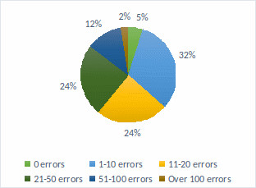
Figure 11. Number of errors identified by WAVE tool.
The number of contrast errors found in web pages varies, but most of these revolving around medium inaccessibility values – 32% of libraries have contrast errors within the range of 11-20. Six of the libraries have absolutely no contrast errors, and only 3 pass the threshold of 100 contrast errors, reaching a maximum of 195 contrast errors.
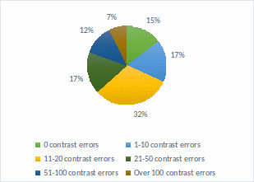
Figure 12. Number of contrast errors identified by WAVE tool.
The number of alerts highlighted by the WAVE tool, leans towards an average level of inaccessibility. Alerts were detected in all libraries analysed, 7 of them exceeding the threshold of 100 alerts. The level of inaccessibility produced by these alerts is questionable, and an evaluator needs to analyse who is capable of determining whether and how issues highlighted by the alerts may affect the accessibility of the website.
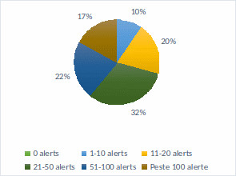
Figure 13. Number of alerts identified by WAVE tool.
The identified features of 34% are at a minimum level (1-10 features), followed by those within the range of 11-20 features (29%) and the range 21-50 (27%), reaching an average level.
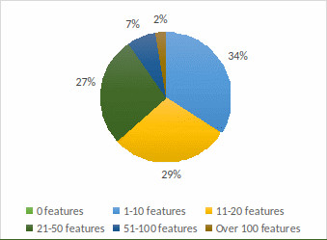
Figure 14. Number of features identified by WAVE tool.
The majority of libraries, at 64%, the structural elements are in the 21-50 and 51-100 ranges, making a visible shift from average to severe inaccessibility problems. The rest of the ranges are representative of an equal number of libraries, less the value of zero that is not valid for any library.
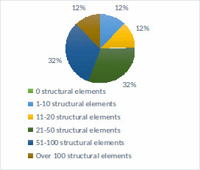
Figure 15. Number of structural elements identified by WAVE instrument.
24% of libraries, the highest percentage, have serious ARIA problems, radically exceeding the threshold of 100, reaching even 781 ARIA problems on a single web page. The next percentage, the 19%, is at the other extreme of the table results, with 8 libraries whose websites do not encounter such problems. ARIA (Accessible Rich Internet Applications) issues have a disastrous impact on web pages, whereas non-compliance with this set of roles and attributes intended for the accessibility of content and web applications will result in a web page that limits the disabled user to navigate it, go through it and understand its content.
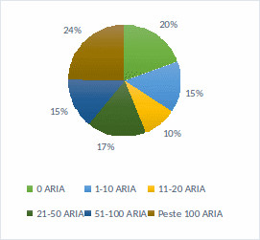
Figure 16. ARIA number identified by WAVE tool.
Using the Website Accessibility Health Score tool, we can see what the accessibility score of the county libraries sites is (by analysing the main page of each library). When using the tool, for technical reasons two sites did not allow analysing them, so we will not consider those sites, and the number of sites rated with this tool is 39.
The analysis found that the general accessibility score of the main web pages of county libraries is between 30%-88%. The highest percentage of libraries (26%) is between the 61%-70% range, followed by another 20% of libraries in the 71%-80% and a single library that falls within the range of 81%-90%, having an accessibility score of 88%. The remaining 20 libraries get lower accessibility values, such as 51%-60% (5 libraries), 41%-50% (6 libraries), 31%-40% (6 libraries) and 21%-30% (3 libraries). Thus, we can say that half of the evaluated libraries (20 libraries), those between the range of 21%-60%, have a low to medium degree of accessibility, while the other half (19 libraries), are between the range of 61%-90%, shows an average to high accessibility (but not maximum).
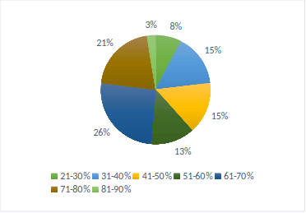
Figure 17. The identified Accessibility Score Website Accessibility Health Score.
When asked „Is the library website an accessible one?”, libraries in the questionnaire used in the previous research, this is where the institution's perspective on its own online accessibility is tracked, 10 of the libraries said they comply with an accessibility standard, 9 responded that general accessibility rules are respected to some extent, and 8 responded that their website does not comply with any accessibility standards. The option „do not know” was also available, which was chosen by four respondents. We opted for the introduction of this answer variant because we could not have information on the skills and level of technological or subject-specific knowledge held by respondents who completed the questionnaire on behalf of county libraries.

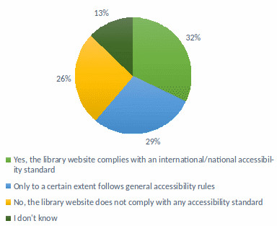
Figure 18. Answers to question 11 – Is the library site an accessible one?
We compared the results obtained with the Website Accessibility Health Score (WAHS) tool to the questionnaire replies. We excluded from this comparison libraries that did not provide a questionnaire reply and the two library sites for which the evaluation using the WAHS tool was not possible. For only 14 libraries, the questionnaire replies correspond to the WAHS evaluation results. Of the 10 libraries that considered having an accessible website, only for 2 this self-assessment was confirmed by the results obtained with the help of the tool, and of the 9 libraries that responded that they would have a partially accessible website, WAHS confirmed self-assessment for 8 only.
To investigate the level of promotion of services specific to people with disabilities on the websites of county libraries, we used as a tool the Google search engine, version „advanced search”. For the investigation, we used the following keywords: accessibility, disability, deficiency, disabled, Braille, Daisy, OCR (Optical Character Recognizer), ramp. The searches were carried out with these keywords and their derivatives.
Of course, not all the results offered by Google that contain these keywords are relevant, so human analysis of all the results obtained was necessary, by accessing web pages delivered by the search engine and critically evaluating their content.
No relevant results were considered and consequently no replies falling under the following situations were taken into account:
- keywords have been found in a context other than accessibility for people with disabilities;
- legislative documents available on the website of the institution that mention the obligation of public institutions to make their products and services accessible, their presence not representing a guarantee that the library complies with those provisions;
- information from official documents, internal regulations, related to employees with disabilities (because the case study concerns disabled users);
- the information that is intended to inform the general public, does not refer to the products, services or the activities undertaken by the library;
-keywords have been found in magazines or books in PDF format available on the library website or in the descriptions of documents in the online catalogue of the library.

Following the searches performed, one or more of the keywords used were found in 33 of the county library sites. The remaining 8 sites did not return relevant results. Eight of the libraries returned relevant results for 4 of the chosen keywords, 8 others provided results for 3 keywords, 6 libraries for 2 keywords, 5 libraries for 5 keywords and only 3 libraries for 6 keywords. No library site has returned relevant results for all proposed keywords (8 keywords).

Tabel 1. Search results for keywords with Google search engine, version „advanced search”.
Keywords | Number of libraries where they were found
accesibilitate (accessibility) | 5
dizabilitate (disability) | 25
deficiență (deficiency) | 24
handicap | 23
Braille | 8
Daisy | 19
OCR | 4
rampă (ramp) | 6

When asked to libraries in the questionnaire, „Does the library provide users with information on the library website related to products and services for disabled people?”, 61% of the libraries replied that they do not provide such information, while 39% said they make this information available to the community.
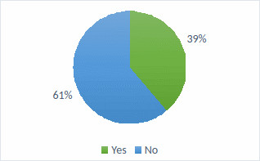
Figure 19. Answers to question 12 - Does the Library provide information on the library's website about products and services for people with disabilities?
Of the 12 libraries that replied that they provide information of interest to users with disabilities, only 10 can be considered as having this type of information available on their own websites (correlating respondents' answers with keyword analysis).

3. Conclusions

Following the analysis of the results obtained through the four tools used for data collection, we can have an overview on the level of accessibility of information at the level of the info documentary structures responsible for informing and integrating the entire community served, without discriminating or disfavouring.
By using a questionnaire in parallel with the other tools, we aimed to approach the comparative perspective of the library and the librarian who completed the questionnaire on behalf of the library, respectively, on behalf of the librarian that filled in the questionnaire on behalf of the library on the level of its accessibility and the results obtained by using the tools available online; thus pondering the subjectivity of the respondents. At the same time, the mix of tools used has allowed for a broader analysis of accessibility issues and, consequently, the creation of a more comprehensive picture of the accessibility of county libraries now.
The research followed three directions, starting from the premise that current libraries must perform hybrid library functions and thus, provide services both in the physical or traditional environment and online: library accessibility, accessibility of the library's website and visibility of information on products and services intended for disabled people.
The low number of accessible documents and the lack of specialized personnel responsible for assisting disabled users concern serious accessibility problems, among county libraries. The results of the research show that 60% of libraries have a small number of accessible documents and 57% among libraries have no specialized staff for training and mentoring people with disabilities in order to use access technologies.
At an average level, the accessibility of library spaces is placed, 39% of county libraries having a partially accessible space.
A higher level of accessibility is reflected by the ownership of access technologies and library entrances, with 68% of libraries providing assistive technologies to users and 74% having entries accessible to all users.
The level of accessibility of library sites varies considerably. 26% of libraries, the highest percentage, have an average level of accessibility, the score being between 61%-70%.
From the perspective of the visibility of information of interest for the needs of people with disabilities, the promotion of specific products and services is weak. Reported on the analysis of county libraries that contributed to data collection, between 61% (according to the questionnaire) and 68% (resulting from the correlation of the responses with the data obtained from the searches made using the keywords) between libraries do not make such information available to the community. Reported only to the data obtained from the searches made with the Google search engine, the advanced version, at the level of the 41 county libraries, a percentage of the level of visibility cannot be established based on the searches for the proposed keywords, as each website contains a certain number of words from the proposed ones, and at the level of each keyword it can be found fewer or more times in the same website.
Even though certain aspects of library accessibility have a medium to high level of accessibility, the ratio between usability and services offered is low, 65% of the libraries serve a low number of disabled users. This fact can be caused by accessibility problems that are found in most libraries, these are huge impediments to the information process or other activities that can be carried out in the library, or the neglect of certain categories of disabilities. Another cause may be represented by the problems of online accessibility, so the inability of disabled users to remotely inform themselves about library products and services, and at the same time, inability to use certain online library services. The visibility of the information of interest, which covers the possibilities of information, documentation, participation in cultural and educational activities, etc., has a significant role in informing users about library services, in attracting new users from the category of disabled people, but also in forming or changing the image of the library from the perspective of accessibility.
Generally speaking, Romanian county libraries present numerous accessibility problems, but there are also positive examples in this respect, which should not be ignored, but promoted and followed as examples of good practices.
These adaptation issues are not library-specific. Lack of accessibility is found at the level of many public institutions and in many areas of activity.
In order to support people with disabilities in the process of information and lifelong learning, but to promote social integration and equalization of opportunities, libraries must overcome their shortcomings, provide disabled users with the same status as valid users and the same importance in establishing specific library practices and objectives.
Currently, more and more libraries are part of a process of modernization of the library, an essential requirement in the current society. This process is an opportunity for integration into library policies and the implementation of adaptation and accessibility requirements for all categories of users.
The possibility to inform yourself, document, train, participate in various cultural events, to communicate within social groups are absolutely necessary activities for the personal and professional development of each individual, promoting integration into society and increasing the quality of life.
Only through an accessible society is social inclusion possible and, finally, improving and normalizing all activities regardless of condition, social status, etc., disability or other aspect that does not have to define the limits or possibilities of a person.

References
Anonymous. (2023) Integrarea socială a persoanelor cu dizabilități și susținerea acestora în procesul de informare prin intermediul bibliotecilor: license thesis. Bucharest: University of Bucharest.

MDN Web Docs. (2024) Available at: https://bit.ly/3X4fTGs

Autoritatea Națională pentru Protecția Drepturilor Persoanelor cu Dizabilități. (2022) Date statistice, 31 decembrie 2022. Available at: https://anpd.gov.ro/web/transparenta/statistici/
WAVE (Web Accessibility Evaluation Tool). Available at: https://wave.webaim.org/

