Scientometric analysis of 3D printing in libraries, and implications for copyright

Mihai Bârsan
PhD.
Email mihai_c_barsan@yahoo.com

Ane Landøy
Norwegian Government, The Directorate for Higher Education and Skills
E-mail ane.landoy40@gmail.com

Ionela Maria Bărsan
Assistant PhD.
Transilvania University of Brașov
Email o.barsan@yahoo.com

Angela Repanovici
Prof. PhD.
Transilvania University of Brașov
E-mail arepanovici@uitbv.ro

Abstract
3D printing is a process whereby users can create a three-dimensional solid object of any shape by operating a 3D printer using a digital design, thereby creating their own designs or replicate and electronically customize scanned objects. The technology has existed for several decades; however, it was not until around 1990 it really gained momentum (Van Wiele, 2019).
3D-printing is a service that is on offer in both public and academic libraries, and there are issues with copyright.
In this paper the authors investigated research on 3D printing in libraries and copyright through a scientometric analysis, by searching in Web of Science for libraries, 3D printing and copyright. The data was mapped in WoS-viewer, to show the most important authors, the most cited documents, and the most cited sources. 107 results from WoS Core Collection for “3D printing” AND copyright was found.
Searching the scholarly literature, it became evident that there are several issues of copyright when it comes to 3D printing: How can the interests of the following key actors “be balanced: (i) rights holders that typically wish to control design dissemination; (ii) design sharing platforms that seek to facilitate design creation and dissemination; and (iii) consumers who require access to digital designs”? (Van Wiele, 2019)
Also, the authors researched library websites in Norway for guidelines and rules concerning copyright and 3D printing. Norwegian copyright law does not mention 3D printing as such, so how are academic and public libraries teaching or mentoring copyright issues to patrons and students?

Keywords: 3D printing, Copyright, Plagiarism, Norway, Libraries

1. Introduction
3D printing is a process whereby users can create a three-dimensional solid object of any shape by operating a 3D printer using a digital design, thereby creating their own designs or replicate and electronically customize scanned objects. The technology has existed for several decades; however, it was not until around 1990 it really gained momentum (Van Wiele, 2019).
The process can be used for technological manufacturing in a business sense. However, in this paper we are mainly looking at 3D printing from the point of view of citizens who want to make something for themselves (or others) as a hobby, and not for monetary gain. We are also investigating libraries (municipal or scholarly) where 3D printing equipment may be found, and where rules and regulations may be explained to patrons wishing to use the equipment.

2. Scientometric study
Scientometrics is an emerging trend and thrust area of scientometrics study that derives quantitative and qualitative research for describing the results of cited documents. https://digitalcommons.unl.edu/libphilprac/4477/
We performed a research study based on direct interrogation of the scientific literature, based on the Web of Science (WoS) database.
We have established that the main research items are composed of Libraries AND 3D printing. The Advanced Search Option was selected for interrogation, and the Query Terms were set to "All fields" with the Boolean "and" value.
After the initial interrogation, a total of 50 articles were shown.

Fig 1: The 50 most cited documents:
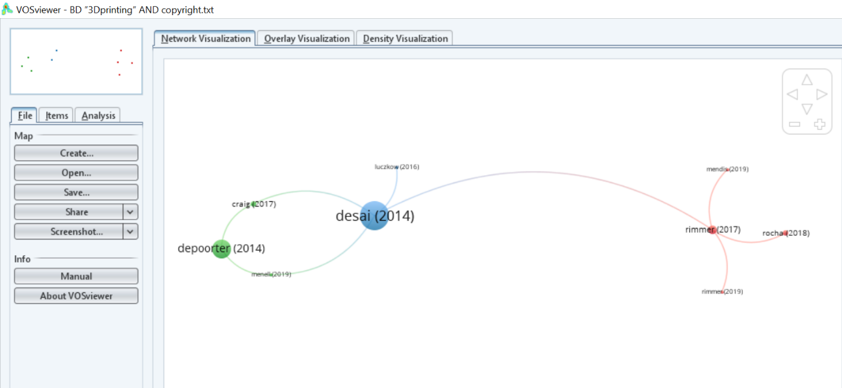

We selected the top cited authors in Table 1
Table 1: Top cited authors
Author | Citations | Links
Bhattacharjee (2016) | 543 | 0
Bishop (2017) | 200 | 0
Despeisse (2017) | 152 | 0
Murr (2016) | 122 | 0
Muwaffak (2017) | 122 | 0
Bates (2016) | 96 | 0
Madamesila (2016) | 58 | 0
Raphael (2017) | 56 | 0
Desai (2014) | 53 | 4
Lin (2018) | 48 | 0
Liu (2016) | 48 | 0
Zhao (2016) | 44 | 0
Hu (2019) | 33 | 0
Domingo-roca (2018a) | 27 | 1
Hou (2017) | 26 | 5
Gardan (2016) | 26 | 0
Alifui-segbaya (2017) | 23 | 0
Depoorter (2014) | 22 | 2
Macq (2015) | 14 | 2
Domingo-roca (2018b) | 12 | 1

The sources where we found documents are show in Fig 2 and table 2
Fig 2: Sources of documents
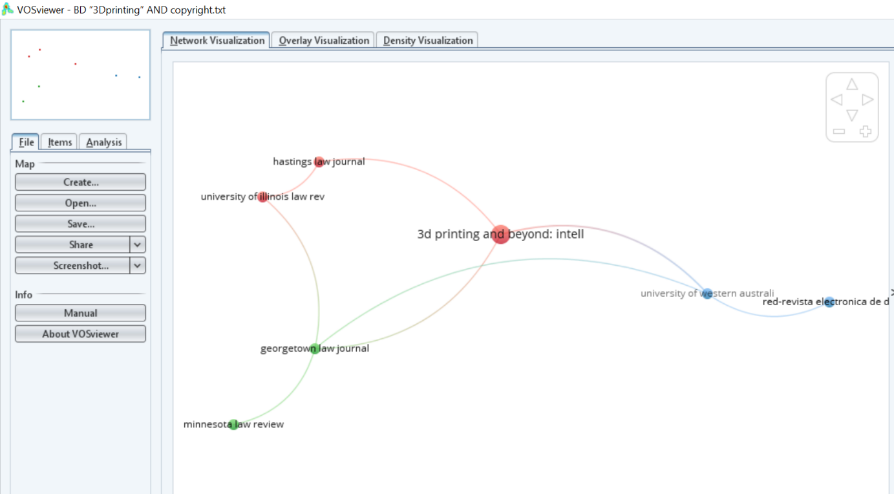

Table 2 Sources for articles in the field
Source | Number of documents
3d printing and beyond: intellectual property and regulation | 3
Epl | 2
Ifac papersonline | 2
Journal of materials science & technology | 2
Materials & design | 2

The most productive countries are USA, Spain, England, Chile, Netherlands. ( see Table 3 )

Table 3 The most productive countries
Country | Documents | Citations
USA | 8 | 942
Spain | 1 | 543
England | 11 | 471
Chile | 1 | 152
Netherlands | 1 | 152
Peoples r China | 5 | 125
South Korea | 7 | 85
Canada | 2 | 58
Germany | 1 | 48
Taiwan | 1 | 48
Scotland | 2 | 39
Australia | 5 | 36
Belgium | 2 | 36
France | 2 | 26
Wales | 1 | 23
Malaysia | 1 | 6
Japan | 3 | 2
Portugal | 1 | 2
Norway | 1 | 1

The co-word occurrence maps drawn show stabilities in the concepts related to the field of Libraries and #D printing. 239 keywords were found. (Fig 3)
Fig 3: Density map of keywords
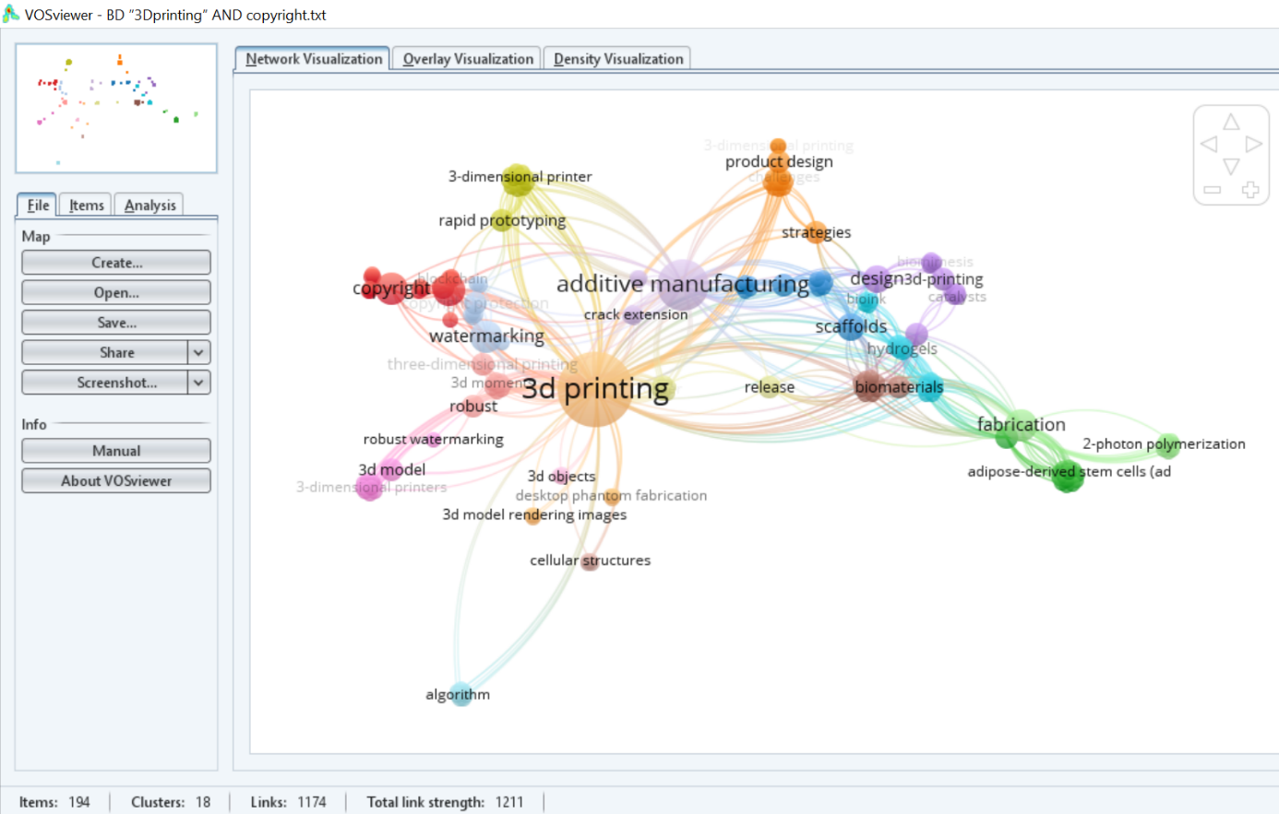

3. About 3D printing:
Mæhlum 2022 explains:
“3D printing, or additive manufacturing, is a collective term for techniques that build objects in solid material based on a three-dimensional digital model. The work is carried out by a 3D printer. The process differs radically from traditional machining, where components are built by separating chips from a workpiece.
In its simplest form, 3D printing occurs when material is extruded in a hot state through a nozzle and adheres to the surface layer by layer. In more advanced printers, powder or wire is used which is melted before it hits the surface. Another principle is that material is applied from a powder bath or bath of liquid substance.
A wide range of material types have proven useful for additive manufacturing: various polymers and plastics, metals, alloys, ceramics and composites, nutrients and biological material.
3D printing has proven to be able to produce components with an internal and external geometric complexity that is impossible to create with traditional chip separation processes. In some quarters, great expectations are attached to additive manufacturing in goods production, and in particular to more specialized components, for example in biotechnology.
3D printing can be traced back to 1983, when American engineer Chuck Hull developed a method of additive manufacturing called stereolithography. A laser beam is guided in a pre-programmed pattern over a vessel with liquid, light-sensitive plastic mass so that the surface layer is hardened by photopolymerization. The substrate for the workpiece is then lowered one notch into the tub for the application of a new layer. Hull patented the method the following year and started the company 3D Systems in 1986.” (Mæhlum 2022, authors’ translation)

3.1 Piracy/Plagiarism

With the emerging possibilities of the new production technologies comes a requirement for legal protection of ideas in this unchartered technological area. Several authors have pointed to the necessity of balancing the needs of different actors: “(i) rights holders that typically wish to control design dissemination; (ii) design sharing platforms that seek to facilitate design creation and dissemination; and (iii) consumers who require access to digital designs” (Van Wiele, 2019), and “3-D printing introduces many copyright infringement issues for digital 3-D objects because the object data can be directly printed and distributed both online and physically. New distribution scenarios not previously considered also pose new content security problems.” (Hou et al, 2018).
Law-making is a somewhat long process, and therefore it can be observed that in many countries, the intellectual property laws and copyright laws are not updated with specific regulations towards 3D printing issues. This may cause problems both for the patrons who would like to legally use 3D designs developed by others, and for designers who are looking to remuneration for their patterns. In this legally uncertain situation, it is vital that citizens are thoroughly informed about the actual regulations concerning intellectual property rights and copyright laws.

4. The practical situation with training on 3D-printing, including copyright issues in the 10 largest academic libraries and 8 major public libraries in Norway

Issues of copyright training in Norwegian libraries was researched in 2015 as part of the international study “Information professionals and copyright literacy: a multinational study”, and the results showed that among the international peers, Norwegian librarians seemed to be feeling less confident when it came to understanding and explaining copyright issues (Todorova et al, 2017). When LIS students’ perceptions were investigated in 2018, the majority of the students did not remember that they had been thought about the issue, even though the curricula and schedules showed copyright as a subject in the teaching (Gastinger and Landoy, 2018)
Norwegian copyright law has a focus on paper based and printing issues. It does not mention 3D printing as such. An area of interest for this research is how academic and public libraries are teaching or mentoring copyright issues to patrons and students as part of training on 3D printing equipment.
Not all libraries in Norway offer training or equipment for 3D printing. The authors chose the to investigate the largest libraries both among public and academic libraries, and looked at their websites, to find out whether they had 3D printing equipment, and if they did, whether training material was accessible and mentioned copyright.

Table 4: 3D printing in the largest municipal and academic libraries in Norway
Library | Training/ CR | Comments | URL
Norwegian University of Technology and Science | Yes/No | Student organisation | https://drive.google.com/file /d/1eU_jJxcn_SYe4PslskZkZ5YizjQRSIk1/view
Univ of Stavanger | Yes/? | Not access to course
Deichman municipal library, Oslo | Yes/No |  | https://deichman.no/vi-tilbyr/3d-skriver_d704d648-f703-46f5-959f-a2219f8feaff
Bergen municipal library | No |  | Bærekraftslaben — Bergen Offentlige Bibliotek (bergenbibliotek.no)
Trondheim municipal library | No/No |  | https://biblioteket.trondheim.kommune.no/innhold/om-biblioteket/tilbud/#heading-h2-6
Sølvberget, Stavanger municipal library | No/No |  | https://www.xn--slvberget-l8a.no/Nyhetsarkiv/Bruk-3D-printer-paa-Soelvberget/(language)/nor-NO
These academic libraries do not have 3D-printing |  | Oslo University, University of Bergen, Agder University, The Arctic University, Univ of South East Norway, Inland College, Volda College. Western Norway College
These municipal libraries in larger cities do not have 3D-printing |  | Tromsø, Bodø, Kristiansand, Ålesund

As may be seen from table 4, 3D printing as a service in Norwegian libraries, both scholarly and municipal, is not widely developed. This is a pity, both for students with design ideas or innovations that need a flexible and available space for testing, and for citizens.
Whereas a digital file of a book, a scan of a book, and a physical copy of a book are usually all considered equivocal copies under Copyright law, the same cannot always be said for 3D printing. In various ways, copyright can protect the design of a 3D object, the file that the printer and programme use to create the object, and the final object.

5. Conclusions
Regarding the library policy for 3D printing, various cases from different libraries around the world have been studied as the perspective offered by the American Library Association, which also includes samples from different libraries in the United States (https://www.ala.org/advocacy/intfreedom/3d printer policy).
Libraries that provide 3D printing services should implement written policies governing the use of these technologies, equipment, and know-how. It is recommended that the following topics be included and explained:
- Determine and recommend which users are eligible to use the library's 3D printer.
- Provide specific rules and regulations regarding user access, fees, and training requirements, including details about printing capacity (printer specifications! );
- Clearly explain which activities are NOT acceptable to be developed using the library's 3D printing facilities (forbidden and illegal);
- Define a STATEMENT (to be signed by the user) informing the user that all other library policies apply when using the library's 3D printer or printing services, including policies addressing user behaviour, acceptable use, cybersecurity, copyright, intellectual freedom, and user privacy;
- Mention the area (real or virtual) where users can access 3D printing educational resources and literacy. https://www.inno3d.eu/module1
Finally, library policy should provide users and librarians with guidance on how to implement policies and manage makerspaces and 3D printing services in libraries (Draghici et al 2021).

6. References
3D Printing and Copyright - Copyright - LibGuides at University of South Florida Libraries, n.d.
The Copyright Act https://lovdata.no/dokument/NL/lov/2018-06-15-40 (in Norwegian)

Draghici A., Lovasz A. & Bursasiu S. (2021). A Debate on Re-engineering the University Library System, In Proceedings of the 11th International Conference on Information Science and Information Literacy (ICISIL 2021)

Hou, J., Kim, D,, Ahn, W., and Lee, H: (2018) Copyright Protections of Digital Content in the Age of 3D Printer: Emerging Issues and Survey. IEEEAccess
Gastinger, A. and Landoy, A. (2018): Copyright Literacy Skills of LIS Students in Norway Microsoft Word - ECIL2018_234-dm-edited (002).docx (uib.no)

Mæhlum, L.: 3D printing in Store norske leksikon at snl.no. Retrieved 24 July 2022 from https://snl.no/3D-printing

Todorova, T.Y.,Kurbanoglu, S.,Boustany, J.,Dogan, G.,Saunders, L.,Horvat, A.,Terra, A.L., Landøy, A.,Repanovici, A.,Morrison, C.,Vanderkast, E.J.S.,Secker, J., Rudzioniene, J.,Kortelainen, T. and Koltay, T. (2017), Information professionals and copyright literacy: a multinational study, Library Management, Vol. 38 No. 6/7, pp. 323-344. https://doi.org/10.1108/LM-01-2017-0007

Van Wiele, B. (2019). Intellectual Property and Consumer 3D Printing University of Cape Town.

